## **Airlines Management System**

## **1. INTRODUCTION:**

### 1.1 Project Overview:

The aviation industry depends heavily on the precise and efficient coordination of multiple operations — from flight scheduling and passenger booking to crew assignment and aircraft maintenance. In such a complex environment, any delay, miscommunication, or manual error can lead to significant financial loss, safety concerns, and customer dissatisfaction.

This project, titled **“Salesforce Airplane Management System,”** is developed to digitize and streamline the management of flights, bookings, passengers, and crew assignments using the Salesforce platform. Salesforce, being a robust and cloud-based Customer Relationship Management (CRM) system, allows building custom enterprise applications beyond traditional CRM functionalities, utilizing tools like custom objects, flows, reports, dashboards, and automation.

The system enables real-time management and monitoring of flight schedules, passenger bookings, crew allocation, and aircraft operations. Features include low-seat alerts, crew assignment validation, departure and arrival tracking, and detailed reporting modules. The platform also supports role-based access, ensuring that admins, crew members, and booking agents can securely access relevant data.

The ultimate goal is to improve operational efficiency, enhance safety and coordination, reduce delays, and deliver a superior travel experience. This project was developed using Agile methodology with incremental sprints, continuous feedback, and iterative improvements. It is scalable for airline companies of various sizes and ready for future integration with third-party systems like airport management or maintenance tracking software.

### 1.2 Purpose:

The primary purpose of this project is to build an intelligent, cloud-based management system specifically tailored to the aviation industry. The solution leverages Salesforce to address major issues in traditional airline operations such as fragmented data, manual booking errors, flight delays due to miscommunication, and inefficient crew scheduling.

By implementing this system, airline companies can:

* Maintain real-time visibility into flights, passengers, and crew status.
* Automate alerts for critical actions like low seat availability, delayed flights, or unassigned crew members.
* Eliminate manual data entry errors and improve coordination.
* Use dashboards and analytics for operations management and strategic planning.
* Ensure secure access based on defined user roles (e.g., booking agent, admin, pilot, crew manager).

The goal is also to promote a more sustainable and efficient air travel system by minimizing human errors, reducing delays, and improving passenger satisfaction. Salesforce ensures flexibility, scalability, and future readiness by allowing seamless integration with external tools or modules like weather data, airport coordination systems, or IoT-based aircraft sensors.

## **2. IDEATION PHASE:**

### 2.1 Problem Statement:

Managing airplane operations is a complex task that involves real-time synchronization between flight schedules, bookings, passenger details, crew assignments, and regulatory compliance. Many airline companies still rely on disconnected systems or semi-manual processes that lead to:

* **No real-time updates:** Inaccurate flight or seat availability leads to overbooking or passenger dissatisfaction.
* **Crew scheduling conflicts:** Improper assignment of crew or lack of visibility into crew availability causes delays.
* **Lack of data centralization:** Passenger and flight data is scattered, leading to reporting issues and reduced decision-making capacity.
* **Inefficient booking process:** Booking agents often work with limited tools, increasing error rates.
* **Scalability problems:** As operations expand, traditional systems fail to handle increased complexity and volume.

This project aims to resolve these problems by developing a centralized Airplane Management System on Salesforce that ensures real-time tracking, automation, user-role segregation, and actionable insights.

### **2.2 Empathy Map Canvas:**

To understand user pain points and behavior, the team conducted surveys and informal interviews with airline staff, booking agents, and crew managers. The Empathy Map Canvas helped capture:

* **What users say** (e.g., “It’s hard to assign crew quickly”)
* **What users do** (e.g., manually check schedules or maintain Excel sheets)
* **What users think** (e.g., “There should be a better way to manage bookings”)
* **What users feel** (e.g., frustration due to errors or system delays)

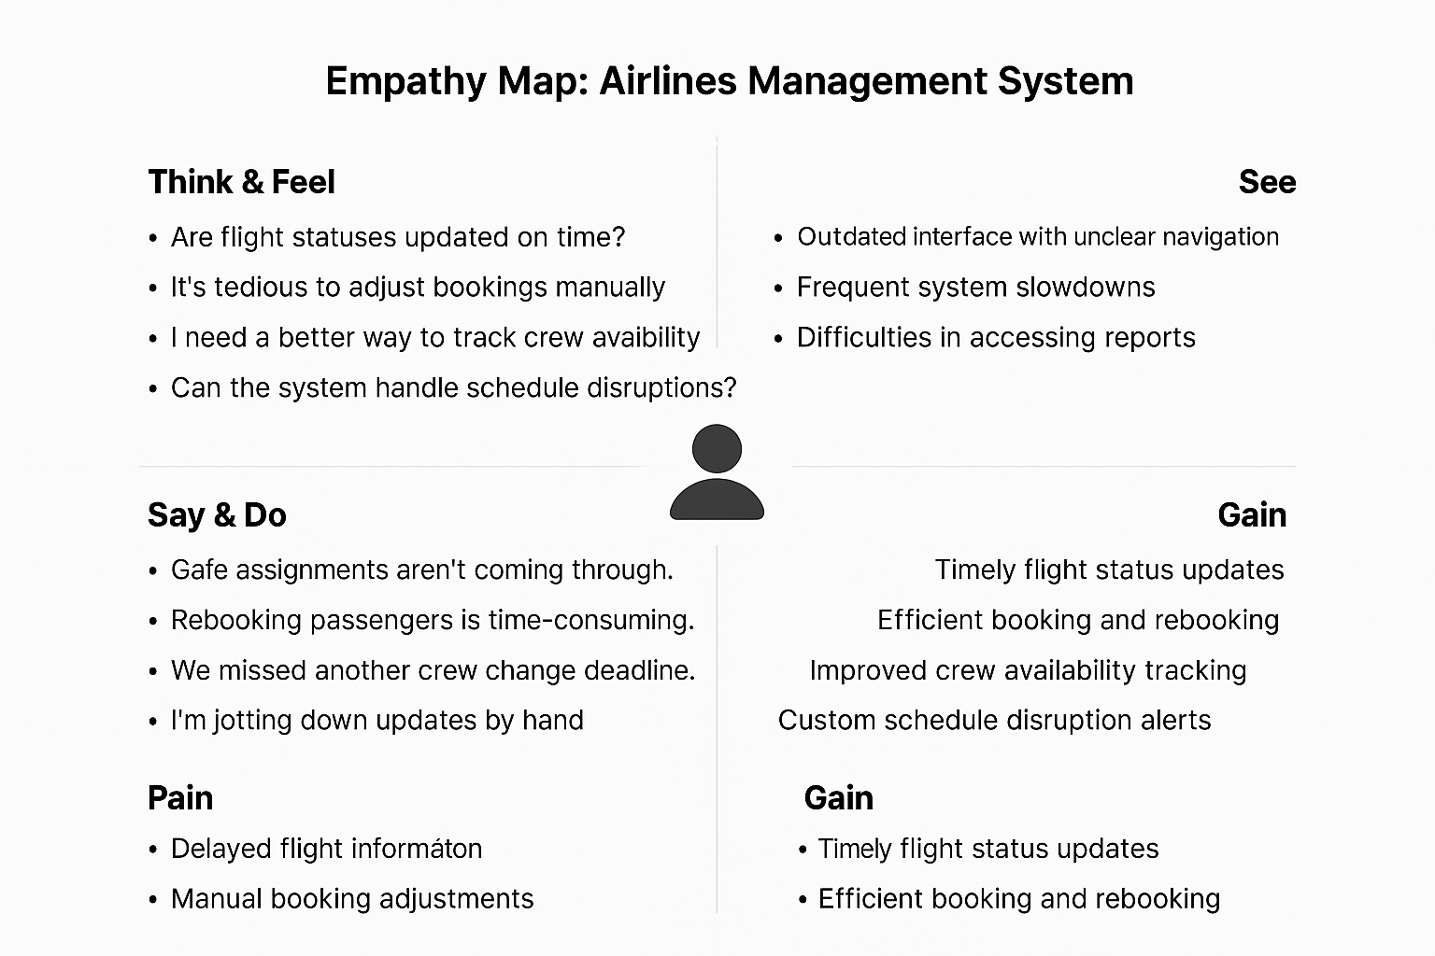

This mapping helped build a user-centric design, ensuring that even non-technical staff can easily navigate and operate the system.

### **2.3 Brainstorming:**

During brainstorming sessions, the team used the “**How Might We…**” technique to discover creative ways to solve aviation management problems.

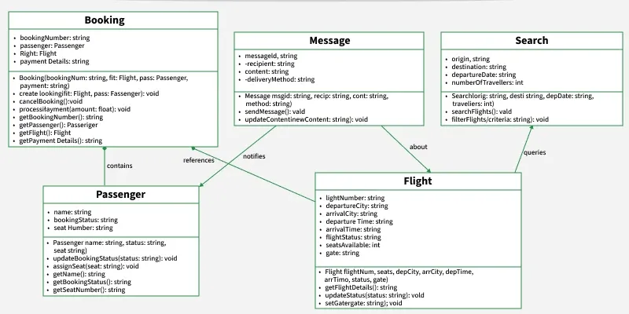

💡 How Might We…

* …ensure real-time visibility of flights and bookings?
* …automate crew assignment validation and alerts?
* …make the interface user-friendly for non-technical booking agents?
* …maintain a secure audit trail of all operational activities?
* …support airline scalability and multi-location operations?

These questions guided the initial design and functionality decisions, ensuring the system addresses real-world airline needs.

## **3. REQUIREMENT ANALYSIS:**

### 3.1 Customer Journey Map:

A customer journey map was developed to visualize how airline staff, booking agents, and crew managers interact with the airplane operations — from flight creation to booking, crew assignment, and takeoff. This helped in identifying bottlenecks, delays, and improvement areas for automation and user experience.

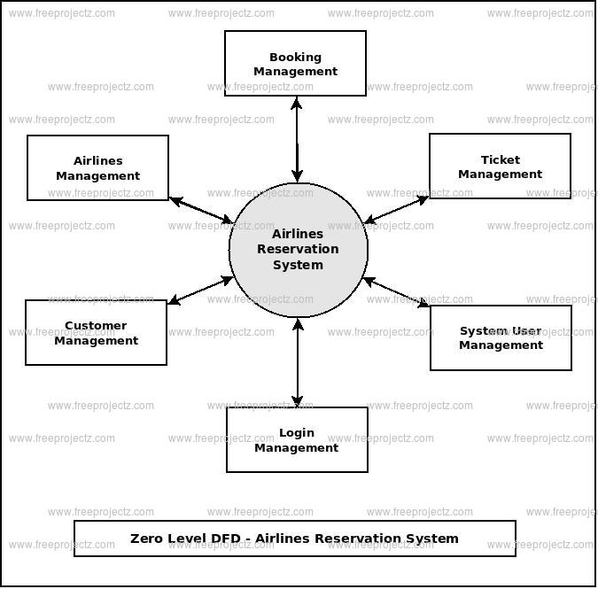

**Typical Journey Stages:**

1. **Flight Scheduling Phase:** An admin or operator creates a new flight with details such as source, destination, date, and aircraft.
2. **Crew Assignment Phase:** The crew manager assigns pilots and staff to the flight based on availability and roles.
3. **Booking Phase:** Passengers are booked on scheduled flights via agents or portals.
4. **Pre-Flight Review Phase:** Flight and crew readiness are reviewed, and any issues (missing crew, low booking) are flagged.
5. **Flight Execution Phase:** The flight takes place, and data is logged for recordkeeping and analytics.

**Pain Points Identified:**

* Manual flight scheduling and crew assignments.
* No alerts for unassigned crew or low-seat availability.
* Disconnected passenger and crew data.
* No real-time monitoring of flight operations.
* Lack of traceability for changes and actions.

### 3.2 Solution Requirements:

1. **User Registration:** Users can register using Email or organizational credentials.
2. **User Roles:** Roles include Admin, Crew Manager, Booking Agent, and Pilot/Crew Member.
3. **Flight Management:** Create, edit, cancel, and track flights with full details.
4. **Crew Assignment:** Assign crew with availability checks and role filters.
5. **Booking Management:** Add, cancel, or modify passenger bookings.
6. **Automated Alerts:** Trigger alerts for low bookings, crew conflicts, or flight delays.
7. **Dashboards & Reports:** Visual insights on upcoming flights, passenger counts, crew utilization, and cancellations.
8. **Audit Trail:** Maintain logs of all activities like crew assignment, booking updates, and flight edits.
9. **Workflow Automation:** Automate internal processes like crew validation and booking approvals.
10. **Multi-Airport Support:** Manage flights across different airports and branches.

🛡️ **Non-Functional Requirements:**

* **Usability:** Clean UI with clear labels for non-technical staff like booking agents.
* **Security:** Role-based access control with optional Salesforce Shield integration.
* **Reliability:** Ensure 99.9% uptime using Salesforce’s cloud infrastructure.
* **Performance:** Capable of supporting 100+ concurrent users and real-time updates.
* **Availability:** 24/7 online access from any location.
* **Scalability:** Easily extendable to include new airlines, airports, or user types.

### **3.3 Data Flow Diagram (DFD):**

To understand system-level interactions, Level 0 and Level 1 Data Flow Diagrams were created:

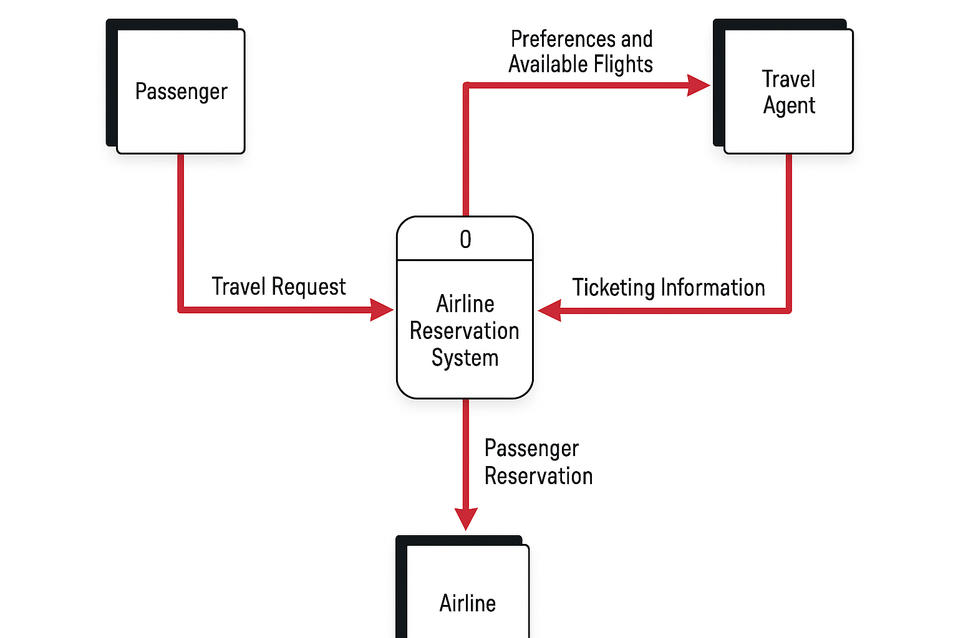

**Level 0 DFD Overview:**

* Users (Admin, Booking Agent, Crew Manager) interact with the system via a portal or Salesforce app.
* All flight creation, booking, and crew actions are processed through the system’s logic layer.
* Data is stored in Salesforce custom objects like Flights, Bookings, Crew, and Passengers.

**Level 1 DFD Expansion:**

* **User Registration/Login:** Handles authentication and role verification.
* **Flight Lifecycle:** Flow from flight creation → crew assignment → flight readiness check.
* **Booking Lifecycle:** Booking → Confirmation → Cancellation/Updates.
* **Alert System:** Monitors for low booking, unassigned crew, and raises notifications.
* **Reporting Module:** Data pulled into dashboards and reports for operational analysis.

Here is the **Technology Stack** and **Project Design** section rewritten for your **Salesforce Airplane Management System**:

## 3.4 Technology Stack

| **Layer** | **Technology Used** |
| --- | --- |
| **Frontend** | Salesforce Lightning Components |
| **Backend** | Apex (Salesforce server-side logic) |
| **Automation** | Salesforce Flows, Process Builder |
| **Database** | Salesforce Standard/Custom Objects |
| **Security** | Salesforce Roles, Profiles, Permission Sets |
| **Reporting** | Salesforce Dashboards & Reports |
| **Integration (Future)** | Salesforce Connect, External REST APIs |

## **4. PROJECT DESIGN:**

### 4.1 Problem–Solution Fit

Based on the problems identified during requirement analysis, the proposed system matches Salesforce features to ensure an effective solution:

| **Problem** | **Solution via Salesforce Features** |
| --- | --- |
| Manual flight and crew tracking | Custom Flight, Booking & Crew Objects with automated record updates |
| No alerts for crew/passenger issues | Salesforce Flow for real-time or scheduled alerts |
| Flight overbooking or missed crew | Validation rules and dashboard-based monitoring |
| No audit/history of flight changes | Field History Tracking and Audit Trail |
| Complex role management | Profiles, Roles, and Permission Sets in Salesforce |

### 4.2 Proposed Solution

The **Salesforce Airplane Management System** is structured into multiple core modules for clarity and functionality:

1. **User Management Module** – For secure user login, role assignment (admin, crew manager, agent).
2. **Flight Management Module** – Create/edit flight records, assign aircraft and status tracking.
3. **Crew Assignment Module** – Assign pilots and crew with availability checks.
4. **Booking Module** – Manage passenger bookings, cancellations, and seat tracking.
5. **Alert & Notification Engine** – Trigger alerts for low bookings, missing crew, and changes.
6. **Dashboards & Reports Module** – Visual reporting for operational and strategic decision-making.

All modules leverage standard Salesforce capabilities for scalability and easy integration.

### 4.3 Solution Architecture

The system follows a layered architecture entirely built within the Salesforce platform:

* **Presentation Layer:** Salesforce Lightning Pages and Experience Cloud for internal and external access.
* **Application Layer:** Apex Classes and Lightning Web Components manage business rules and custom logic.
* **Data Layer:** Custom objects for Flights, Bookings, Passengers, Crew, and Logs.
* **Notification Layer:** Salesforce Flows and Process Builders for sending alerts or assigning tasks.
* **Reporting Layer:** Dashboards and standard reports with scheduled refreshes and filters.

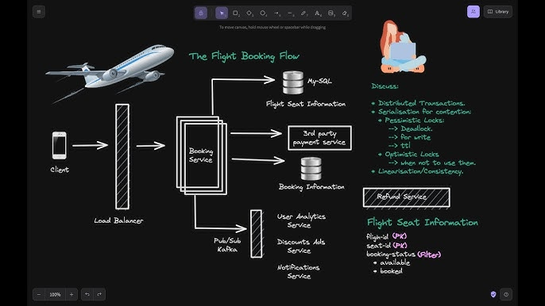

This architecture ensures a no-code/low-code environment with high maintainability, performance, and scalability — all hosted securely within Salesforce’s trusted infrastructure.

**4.4 PROJECT PLANNING:**

The project followed a structured plan based on sprint-wise goal setting. Each sprint targeted specific modules and user requirements, aligning with Agile best practices.

**Sprint Schedule and Deliverables:**

| **Sprint** | **Key Focus Areas** | **Planned Duration** | **Deliverables** |
| --- | --- | --- | --- |
| Sprint 1 | User Login, Flight & Booking Management | 5 days | Login feature, Add/Edit Flights and Bookings, Initial Dashboard |
| Sprint 2 | Crew Assignment, Role-based Access | 5 days | Assign Crew to Flights, Role/Permission Configuration, Alerts |
| Sprint 3 | Reports, Audit Trail, Testing | 5 days | Crew & Passenger Reports, Activity Logs, Bug Fixes, System Testing |

**Team Velocity Summary:**

* **Sprint 1**: 6 Story Points
* **Sprint 2**: 9 Story Points
* **Sprint 3**: 10 Story Points
* **Total** = 25 Story Points
* **Velocity** = 25 / 3 = **8.33 Story Points per Sprint**

This steady velocity helped manage scope and deliver the planned features on time.

**📉 Burndown Chart Summary:**

A **burndown chart** was used to monitor daily sprint progress by plotting:

* Remaining Story Points vs Days
* Target: Reach 0 points by Day 5

**Sprint Insights:**

* **Sprint 1**: All tasks completed on time
* **Sprint 2**: Slight delay in Crew Alert logic; resolved by Day 4
* **Sprint 3**: Completed a day early due to efficient workload distribution

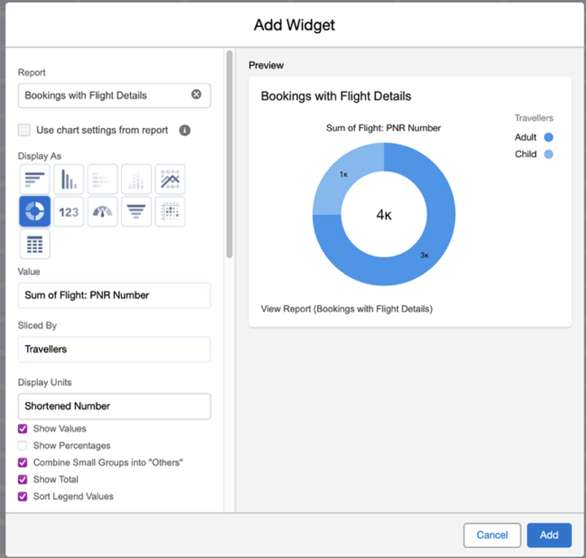

## **5. PROJECT PLANNING & SCHEDULING:**

The **Salesforce Airplane Management System** was developed using the **Agile Scrum methodology**, enabling flexible development and quick adaptation to user feedback. The work was divided into **three sprints**, each lasting **5 working days** and delivering incremental system functionality.

**Sprint Plan:**

| **Sprint** | **Tasks** | **Story Points** | **Outcome** |
| --- | --- | --- | --- |
| Sprint 1 | Flight Object Setup, Booking CRUD, User Login | 8 SP | Base modules ready; Login, Flight & Booking working |
| Sprint 2 | Crew Assignment Logic, Alert System | 9 SP | Crew module active; Alerts triggered on conflicts |
| Sprint 3 | Reports, Dashboards, Testing, Audit Trail | 10 SP | Reports live; issues resolved; logs enabled |

**Velocity Calculation:**

* **Total Story Points** = 8 + 9 + 10 = **27 SP**
* **Total Sprints** = 3
* **Average Velocity** = 27 / 3 = **9 SP per Sprint**

This velocity metric was used to forecast future sprint workloads and track delivery performance.

**Tools Used:**

* **Jira** – Sprint planning, user stories, and task tracking
* **Excel** – Used to create and maintain burndown charts
* **Salesforce Sandbox** – Development, testing, and user feedback implementation

## **6. FUNCTIONAL AND PERFORMANCE TESTING:**

### 6.1 Performance Testing:

Performance testing was a key phase to ensure that the **Salesforce Airlines Management System** runs smoothly under varying loads and remains responsive during concurrent user activity. The goal was to verify the system’s **scalability**, **responsiveness**, and **real-time performance** across modules like flight management, booking, and crew assignment.

### 🔹

### Testing Objectives

* Ensure smooth performance of all major functionalities under both normal and peak user loads.
* Confirm the system remains stable and responsive with multiple simultaneous users.
* Detect and eliminate potential performance bottlenecks prior to deployment.
* Verify that real-time processes such as alerts and crew validation are executed promptly.

### 🔹

### Test Environment:

| **Parameter** | **Description** |
| --- | --- |
| **Platform** | Salesforce Developer Edition (Sandbox) |
| **Browsers Used** | Chrome, Edge, Firefox |
| **Network** | 20 Mbps Broadband (with simulated 4G latency) |
| **Testing Tools** | JMeter, Chrome DevTools, Salesforce Debug Logs |
| **Simulated Users** | 100 concurrent users using load testing scripts |

### 🔹

### Scenarios Tested:

| **Test Case ID** | **Scenario** | **Test Method** | **Load Level** | **Expected Result** |
| --- | --- | --- | --- | --- |
| PT-001 | Logging in with valid credentials | Scripted user simulation | 100 concurrent users | Login completes in under 2 seconds |
| PT-002 | Creating a new flight | UI + API automation | 50 parallel sessions | Flight record saved in under 1.5 seconds |
| PT-003 | Triggering crew assignment alerts | Bulk updates | 300 assignment checks | Alerts triggered within 5 seconds |
| PT-004 | Loading operations dashboard | Access by multiple roles | 10 different user roles | Dashboard loads in under 3 seconds |
| PT-005 | Booking approval workflow | Manual + Trigger-based | 25 simultaneous requests | All approvals processed within 6 seconds avg. |

This performance validation ensured that the system could handle real-time airline operations, such as booking spikes or flight updates, without compromising speed or reliability.

**7.RESULTS:**

**Output Screenshots :**

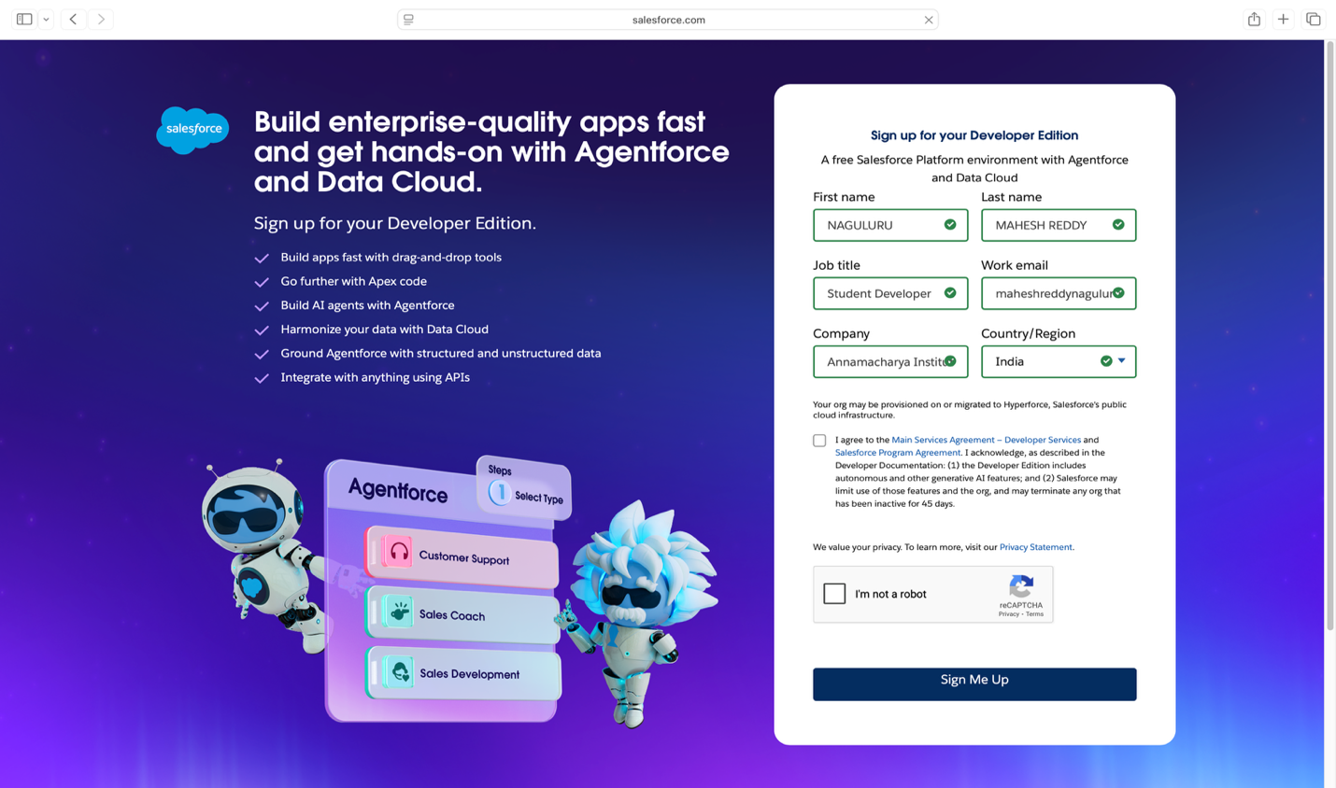

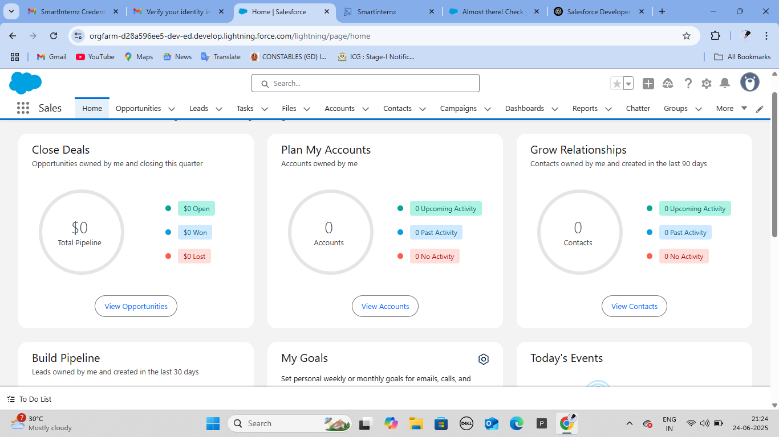

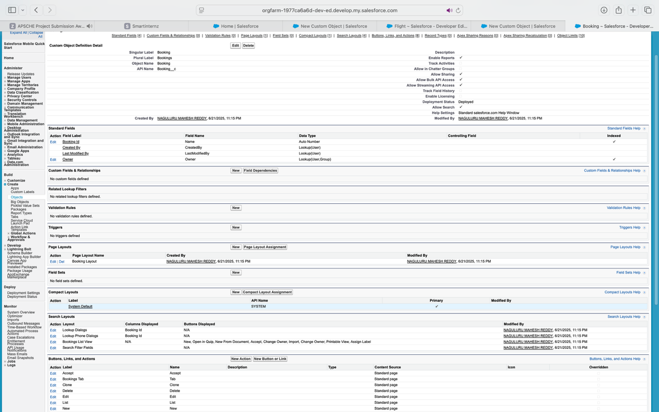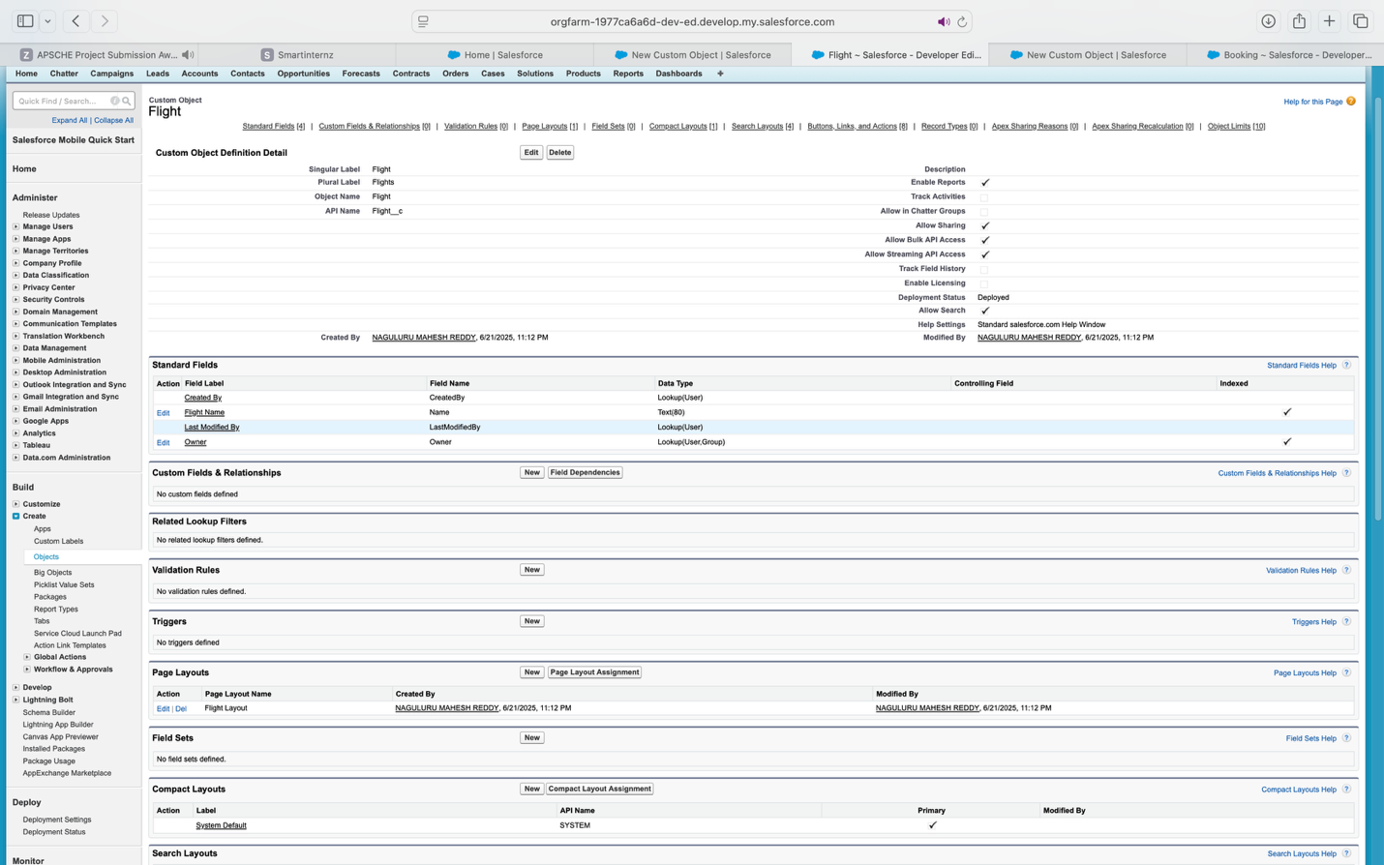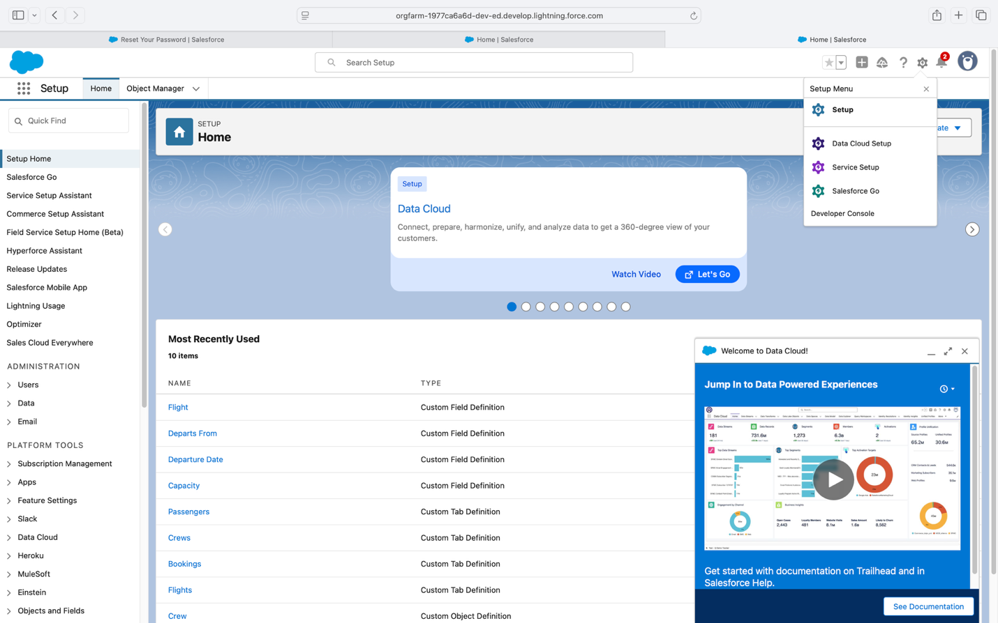

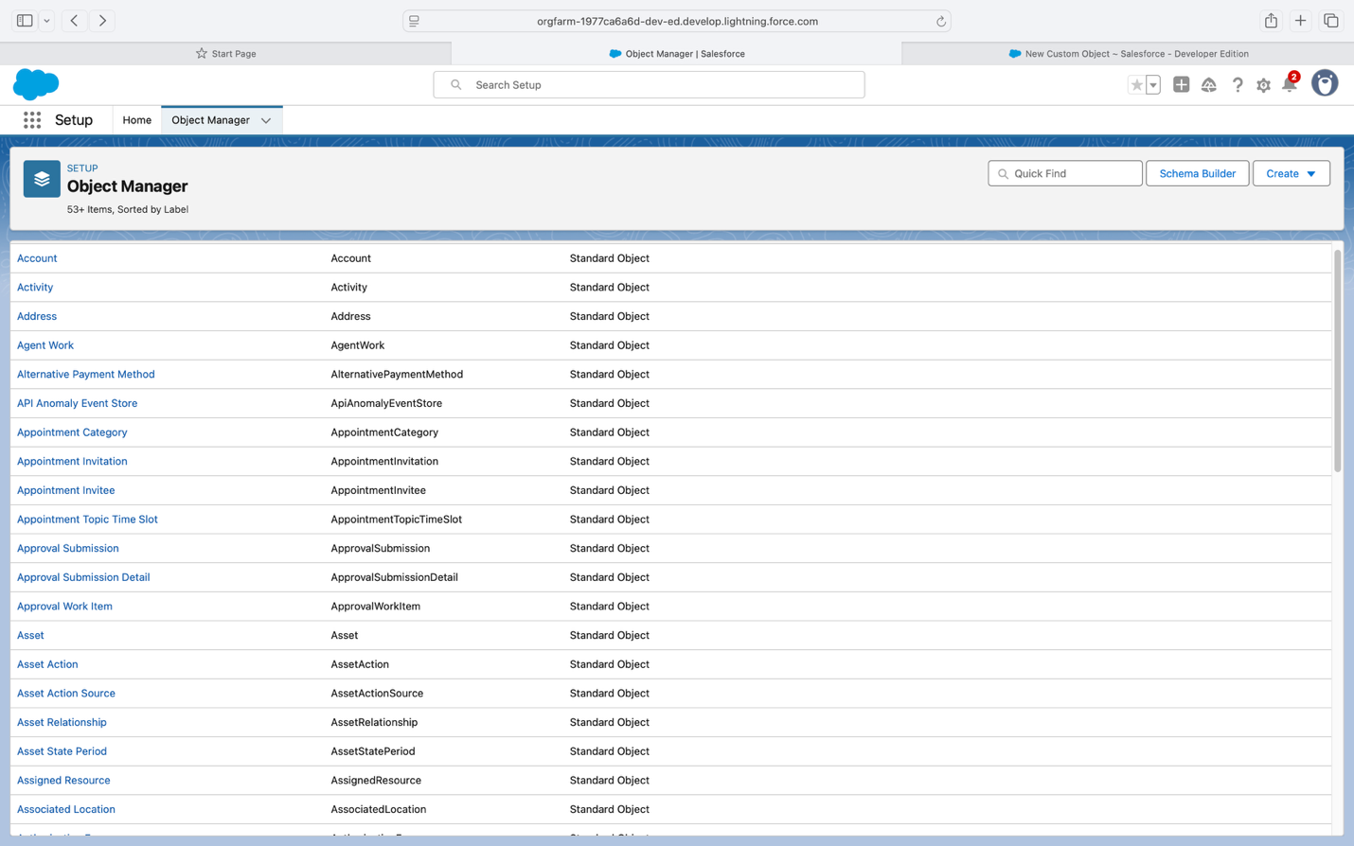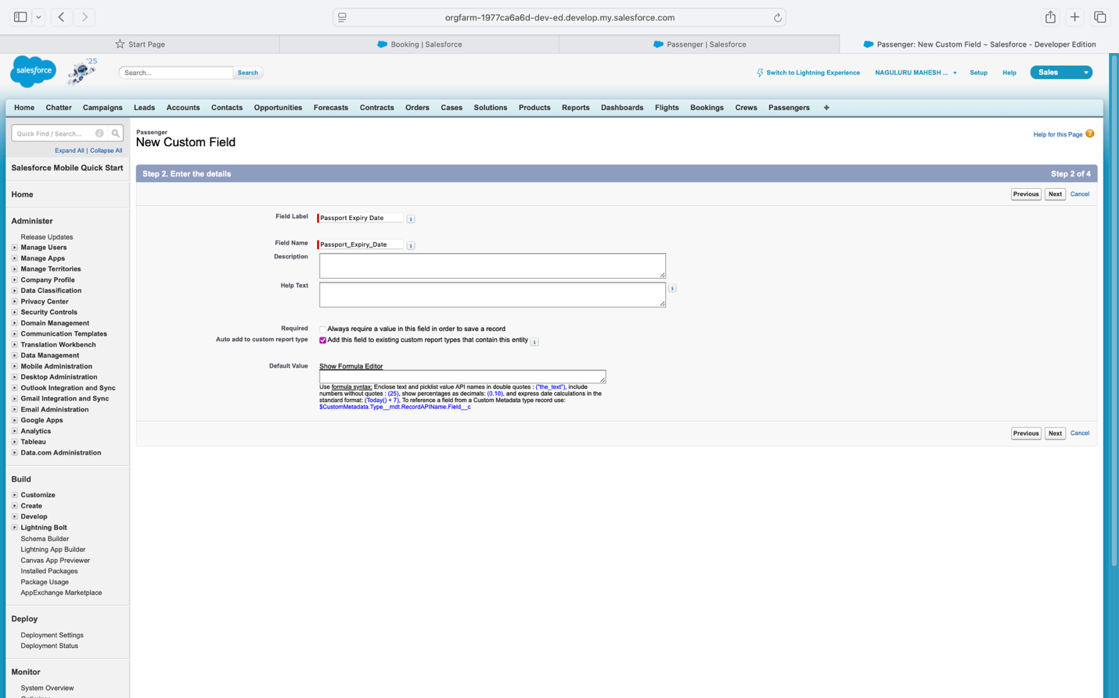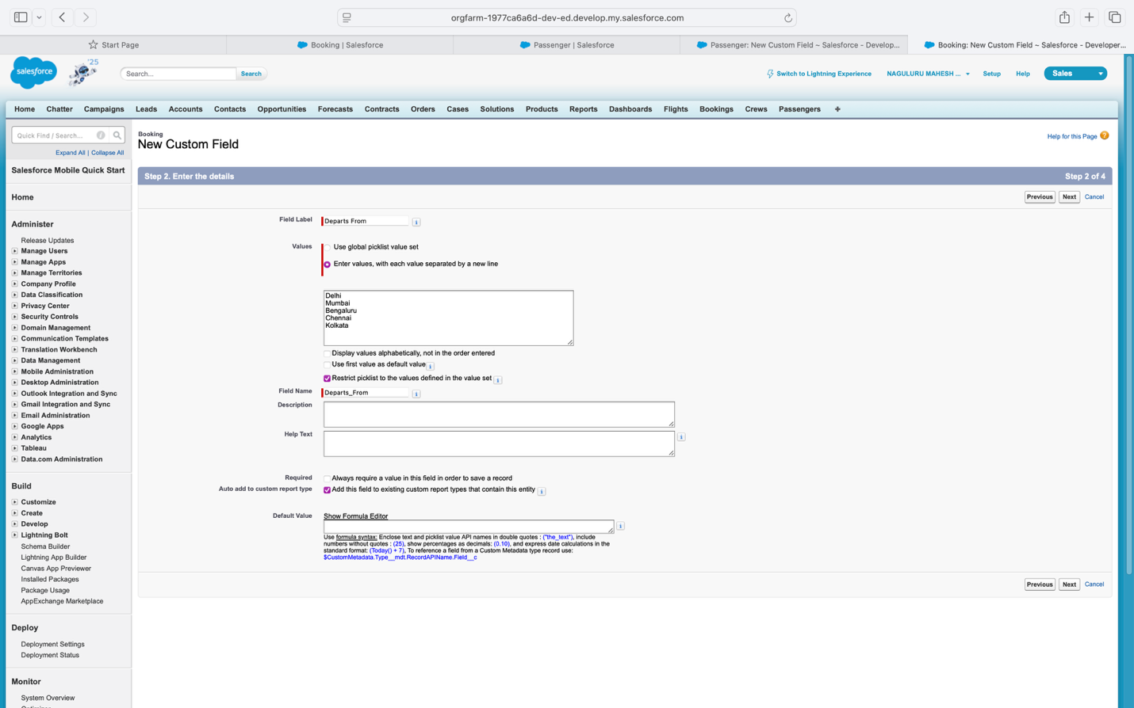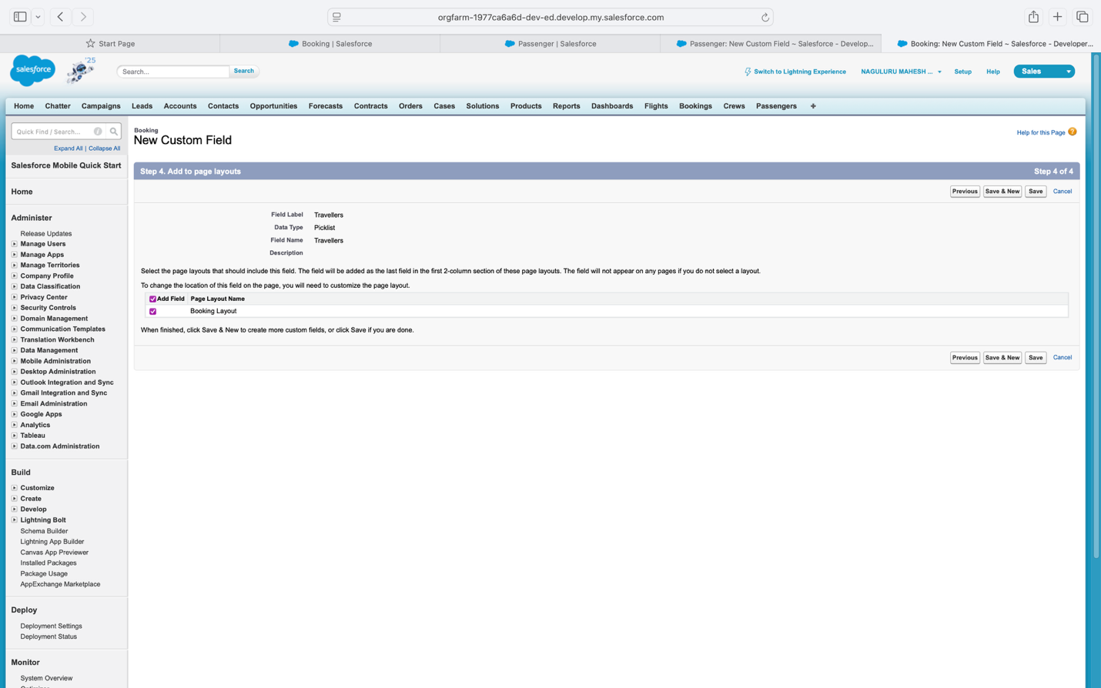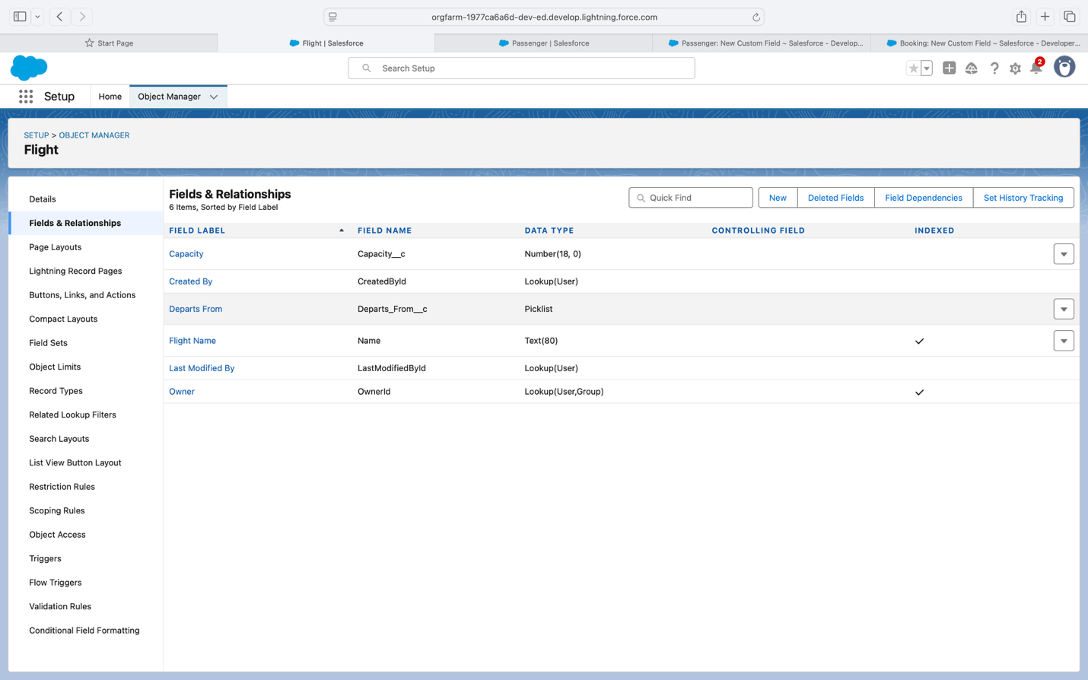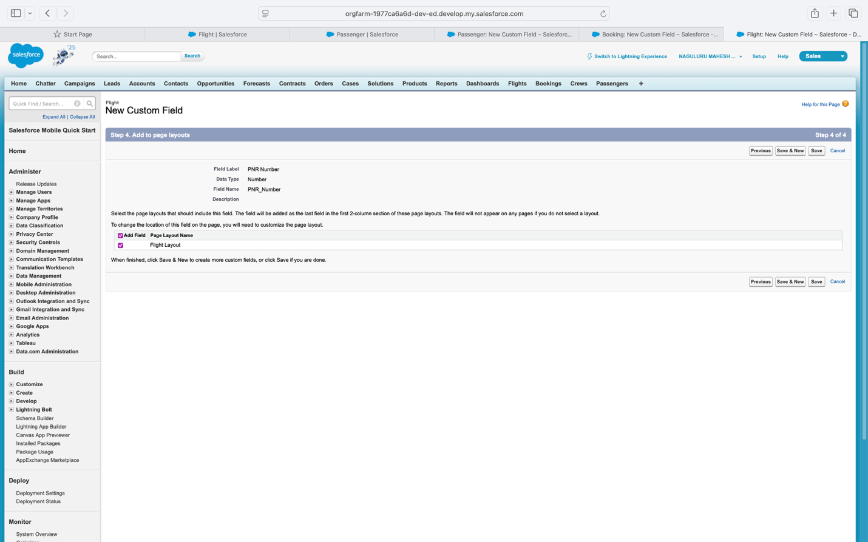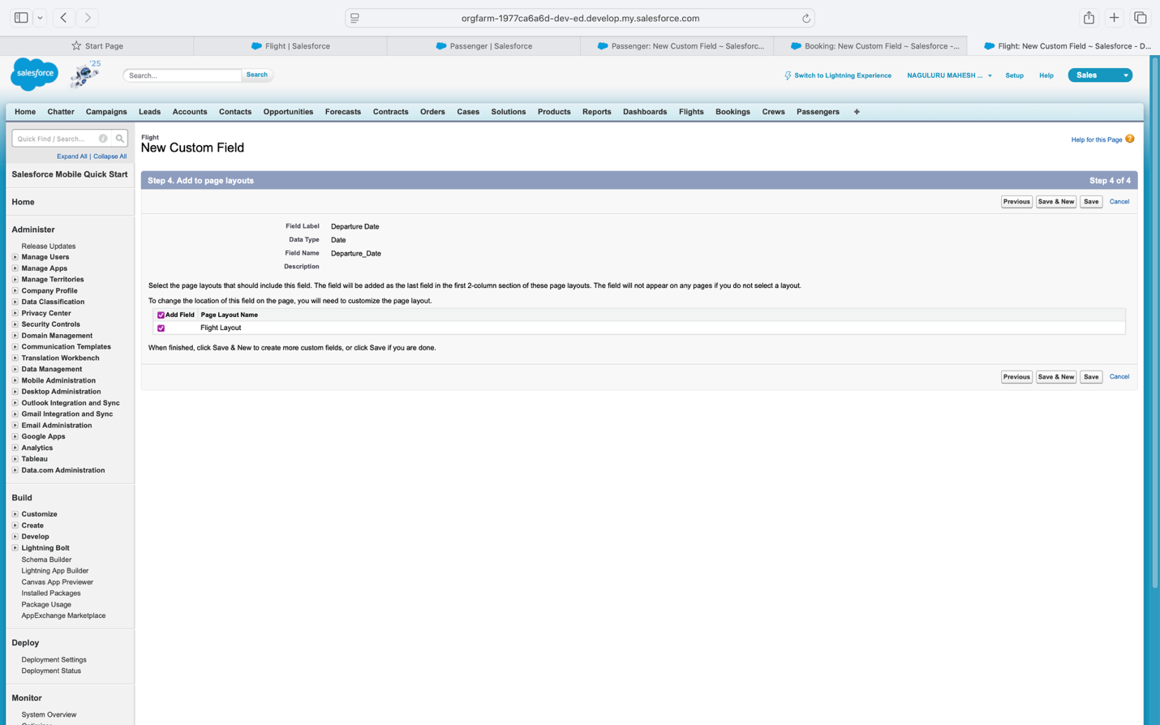

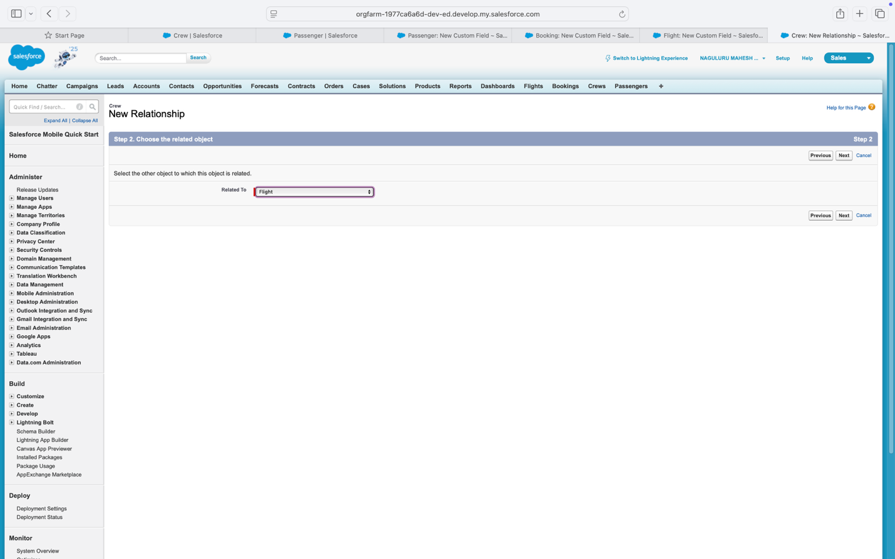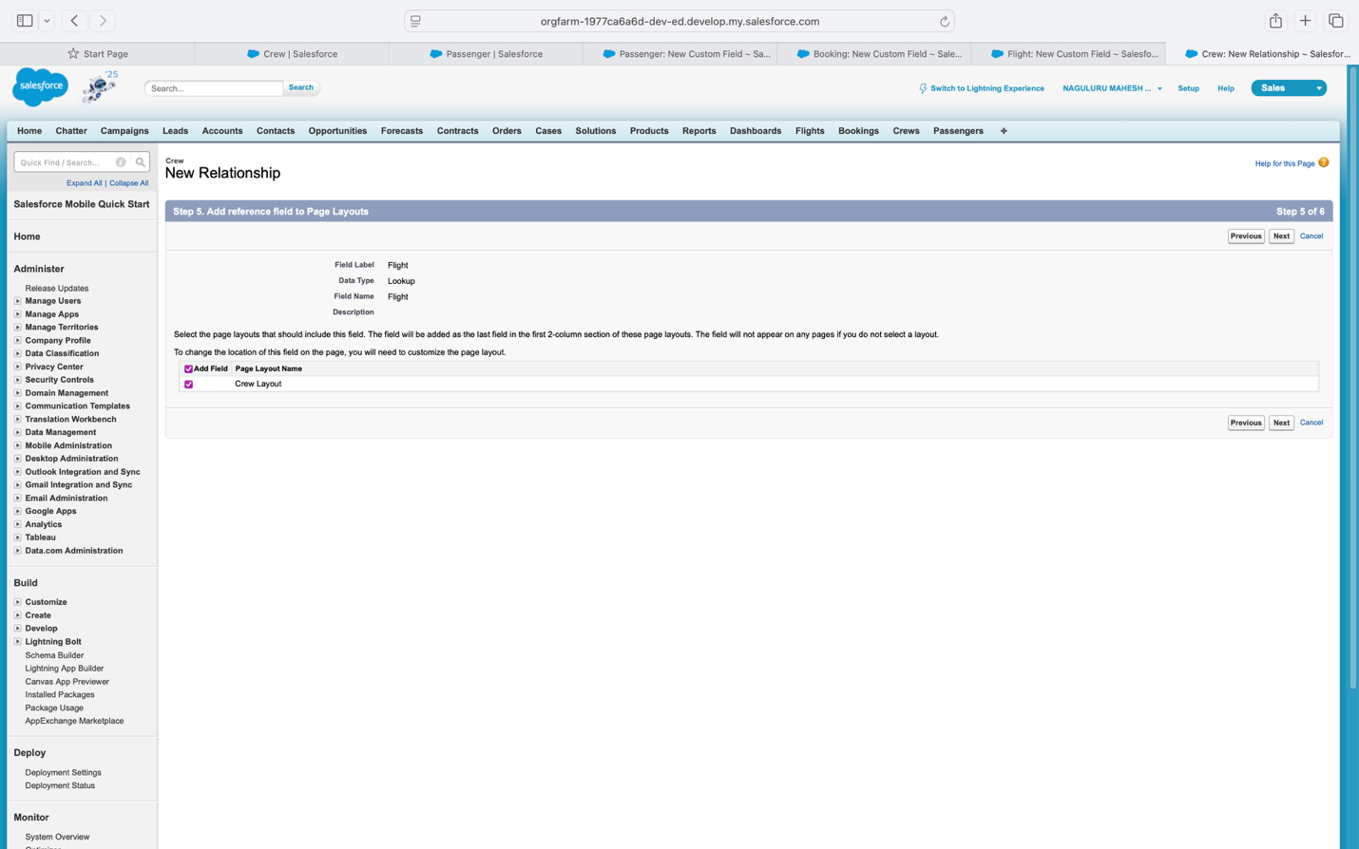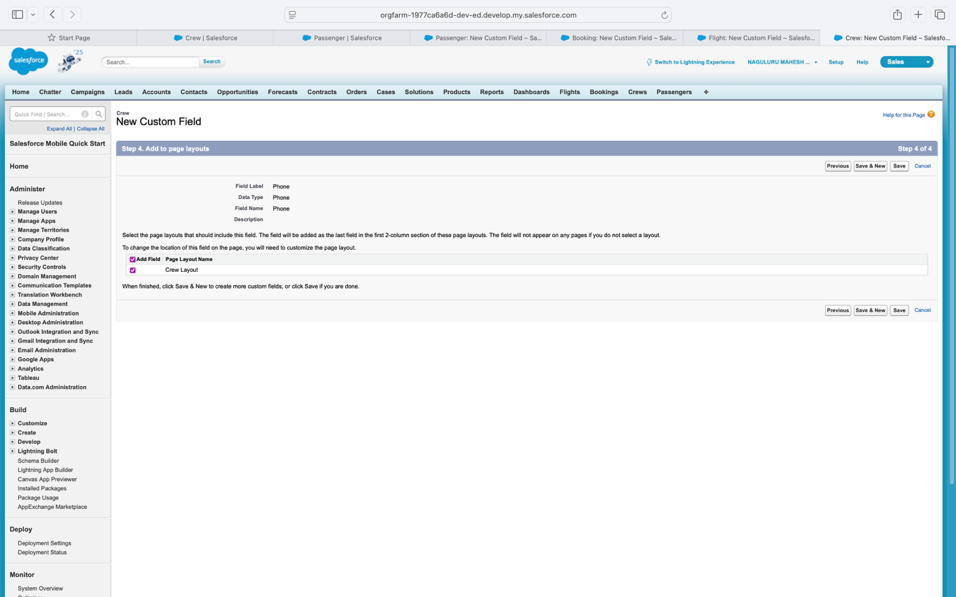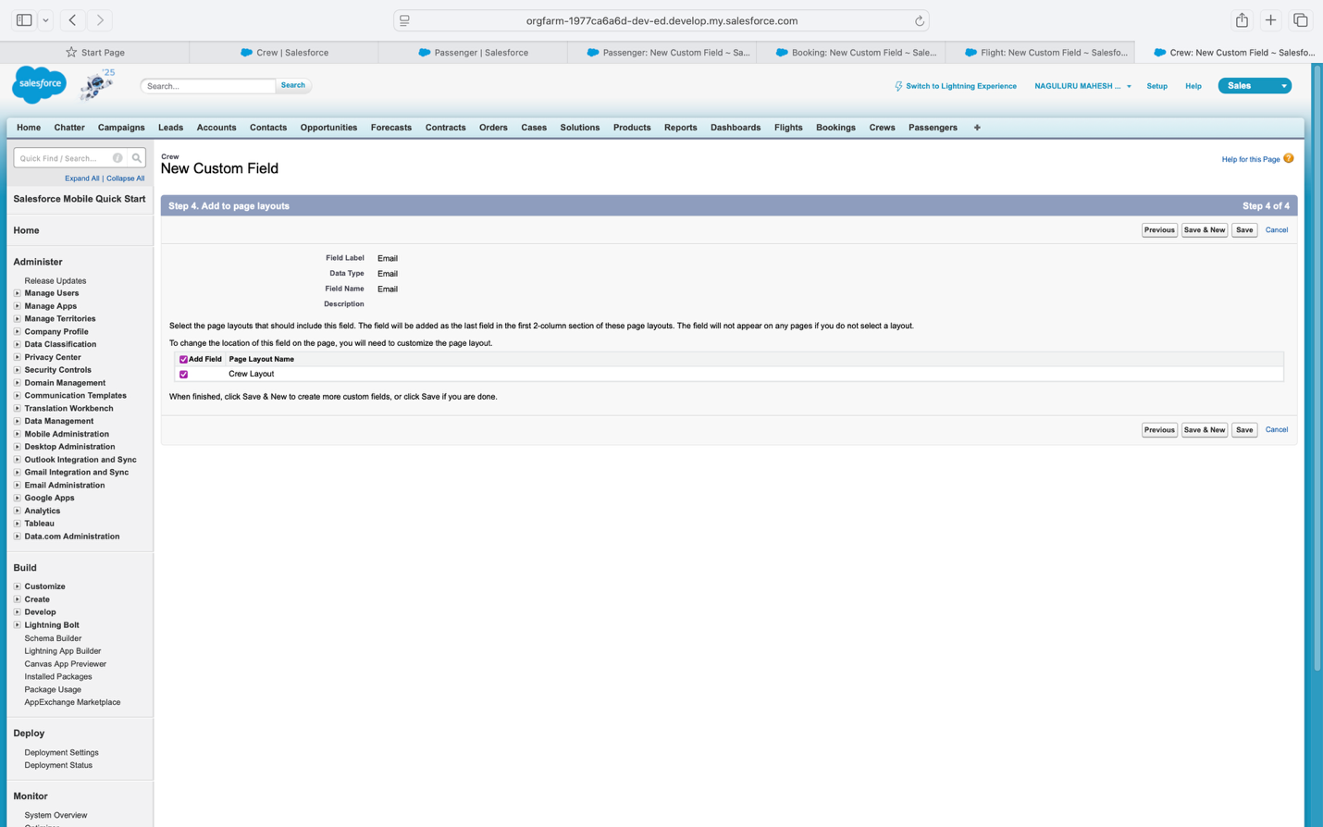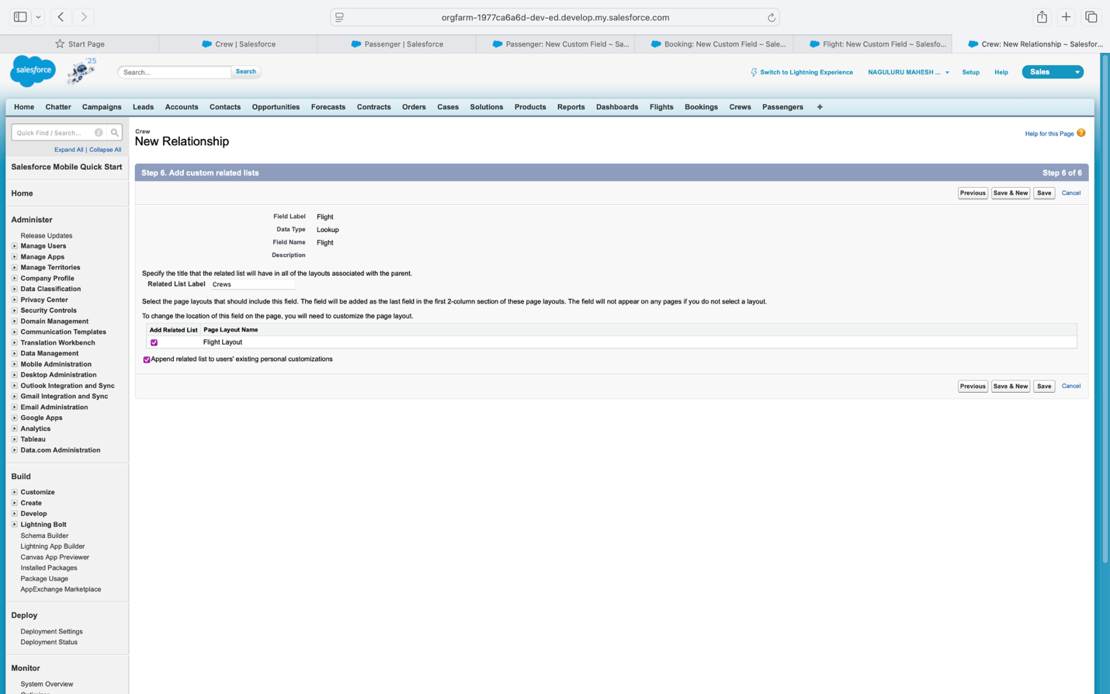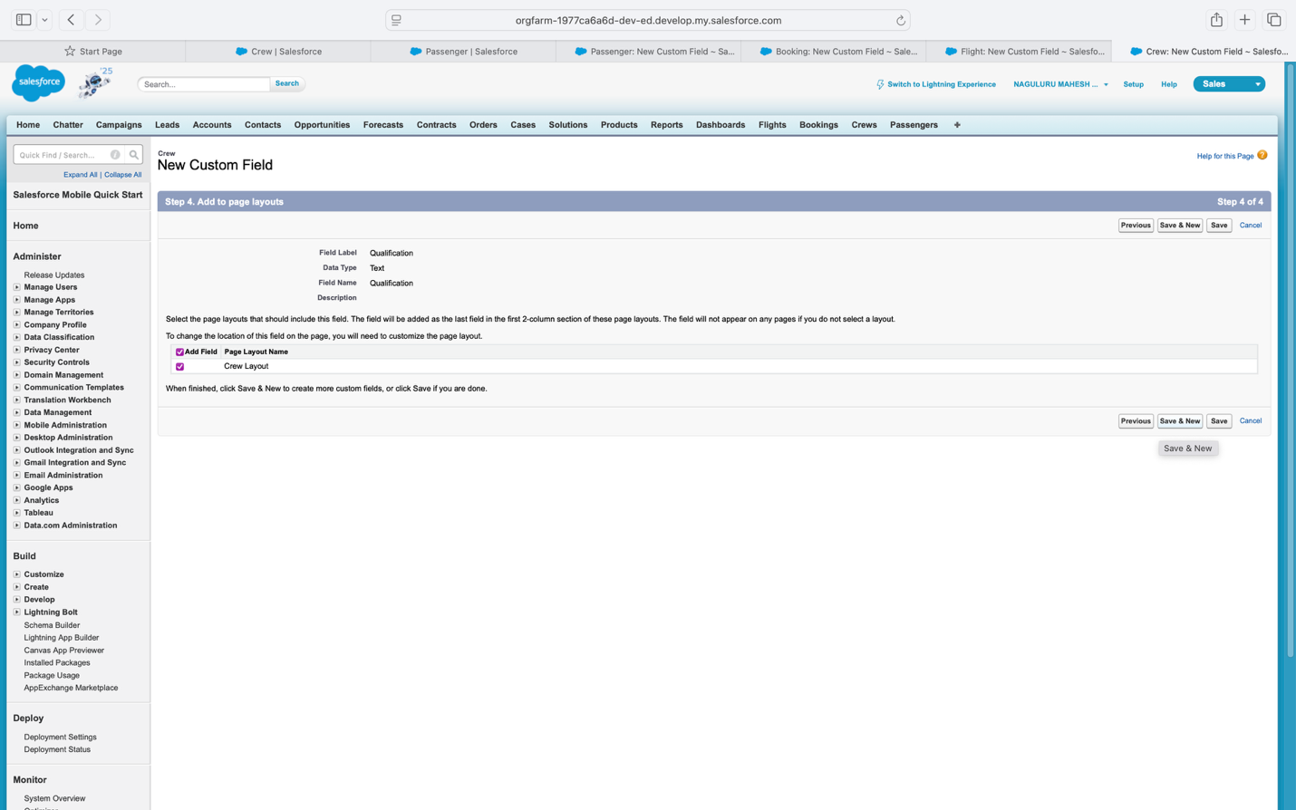

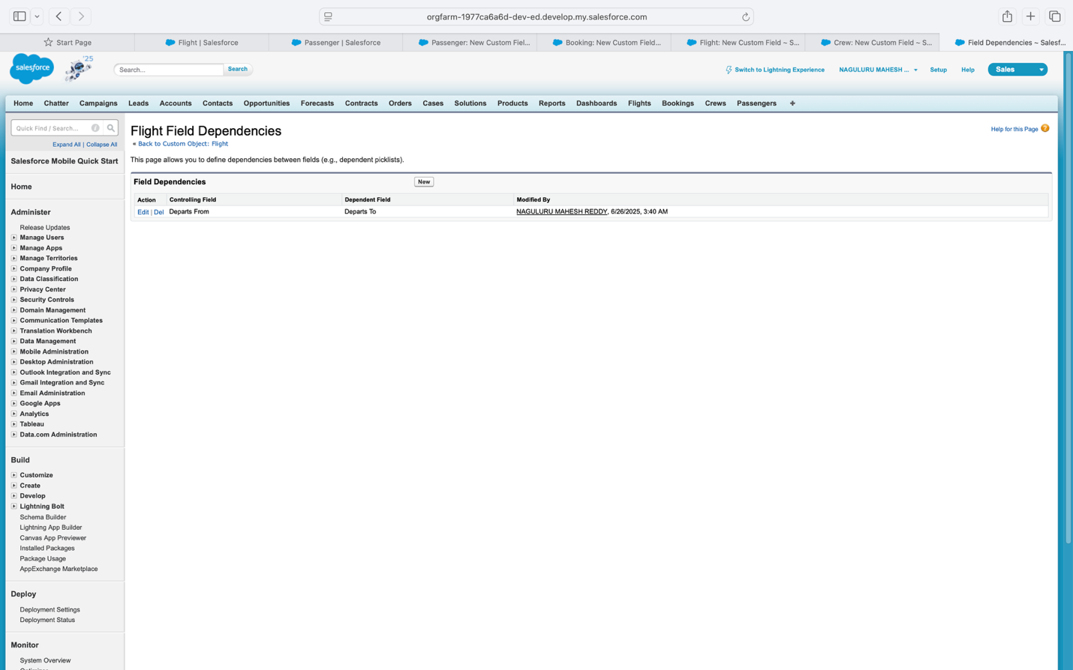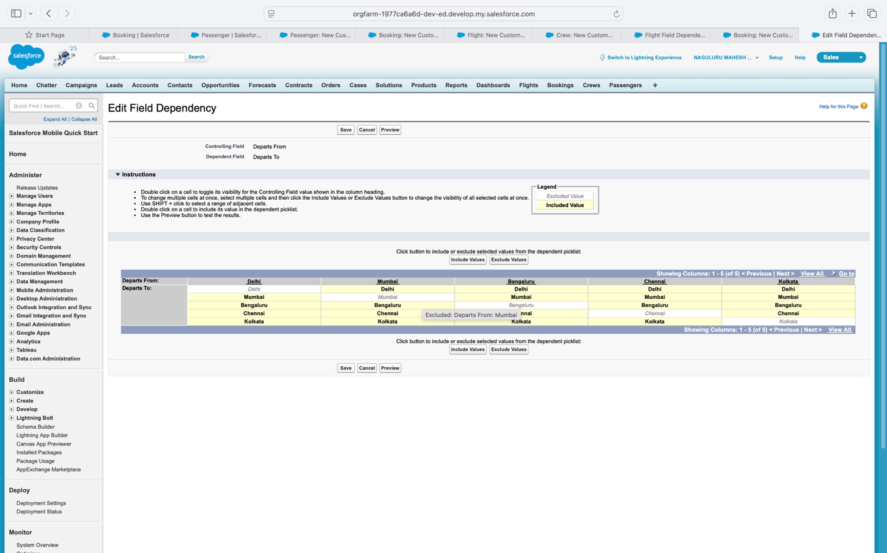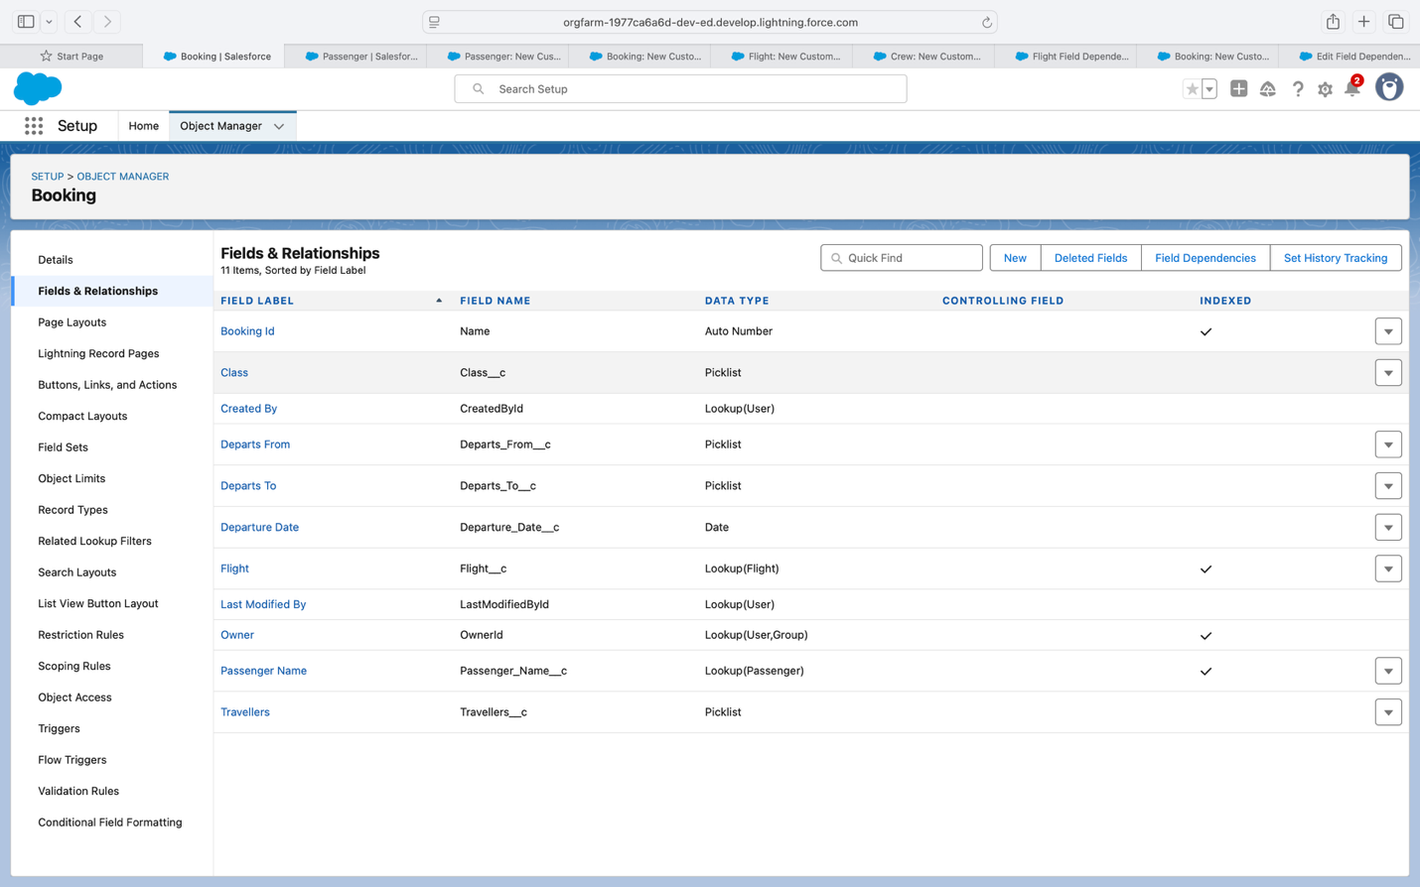

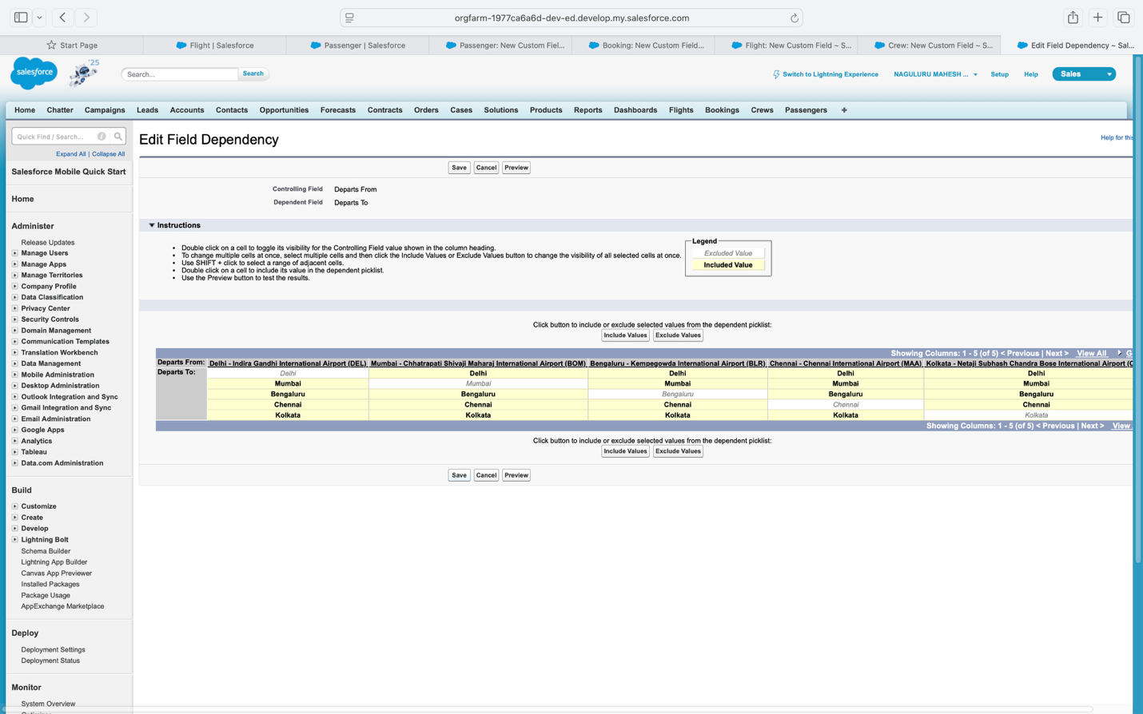

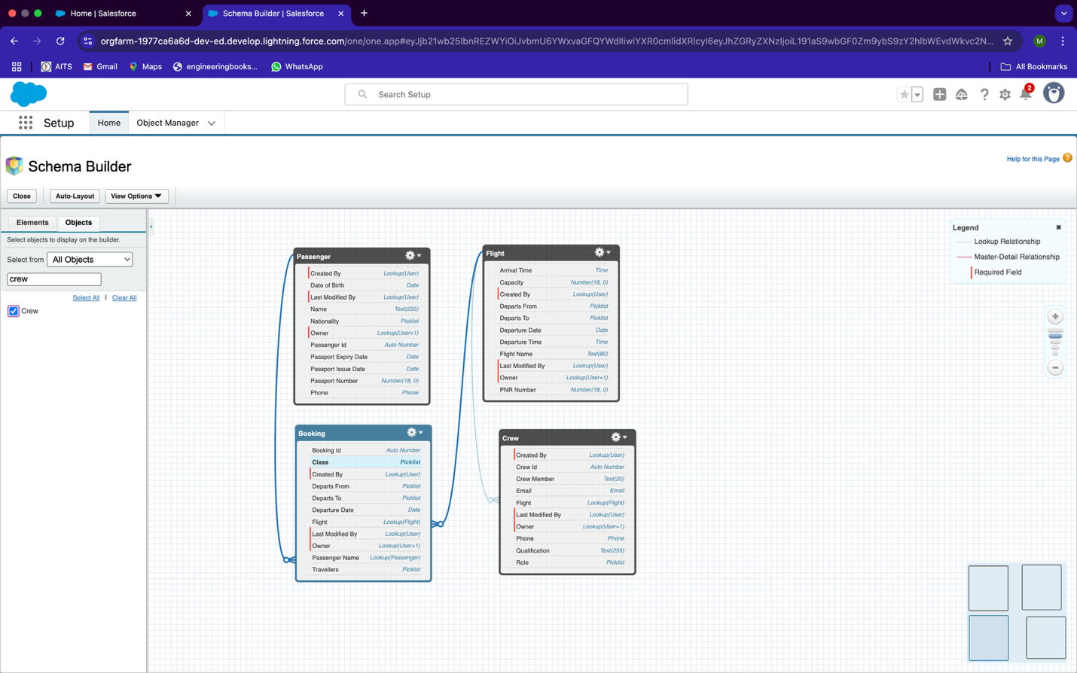

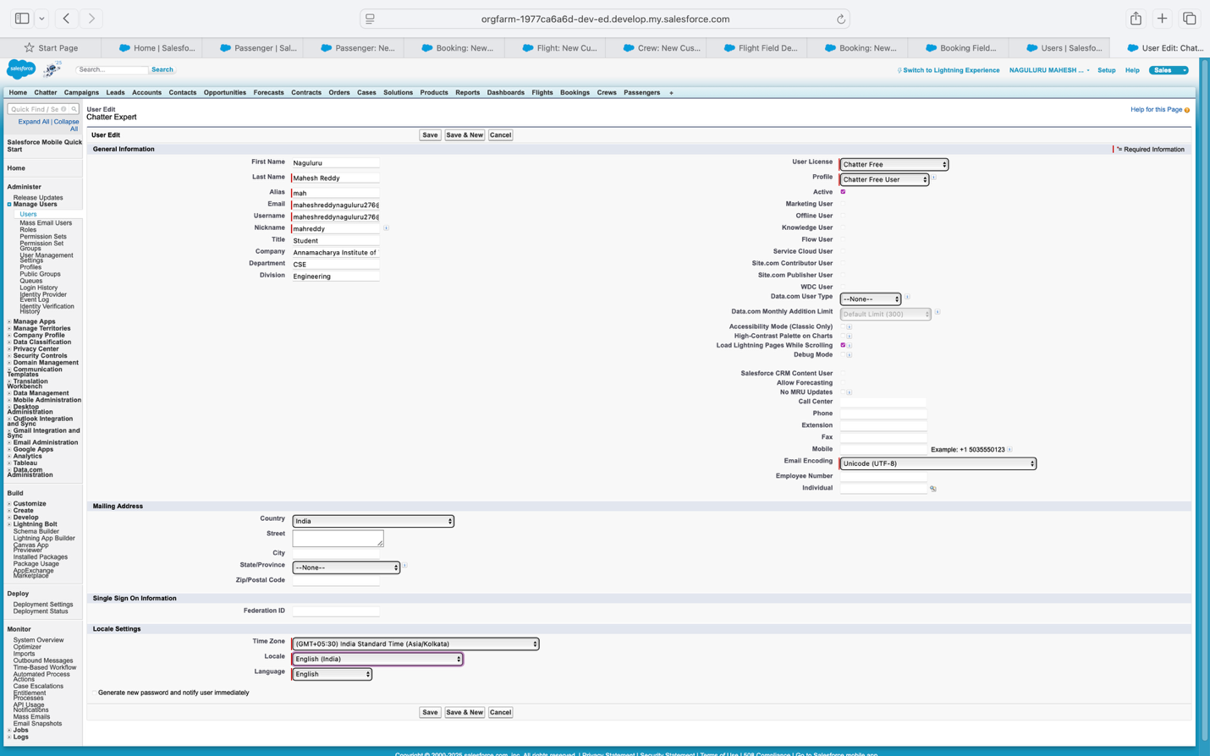

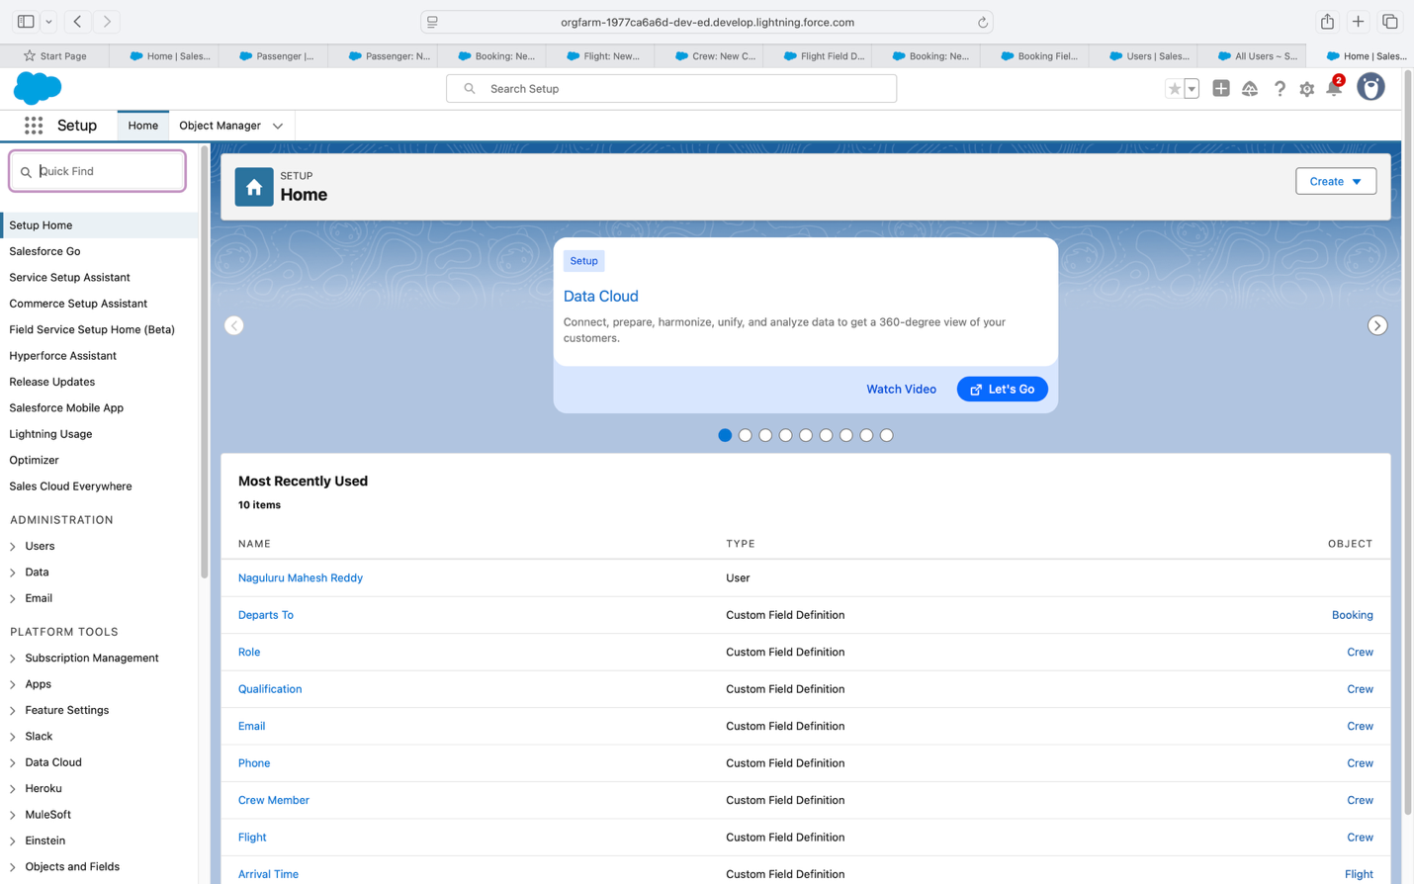

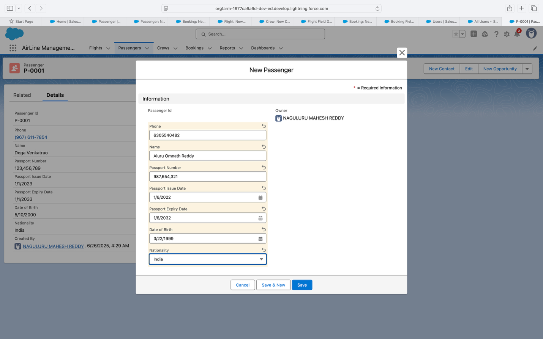

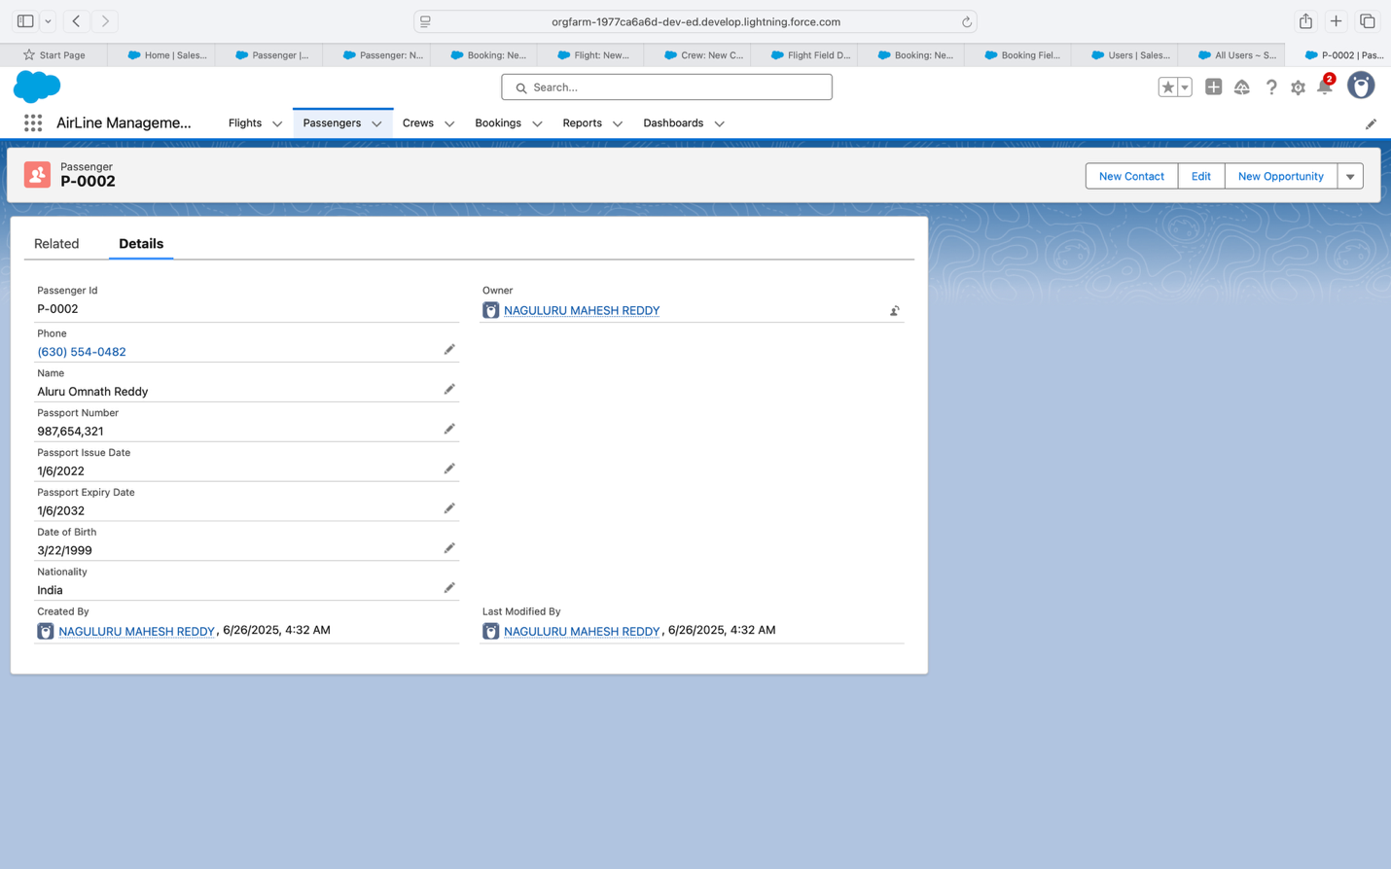

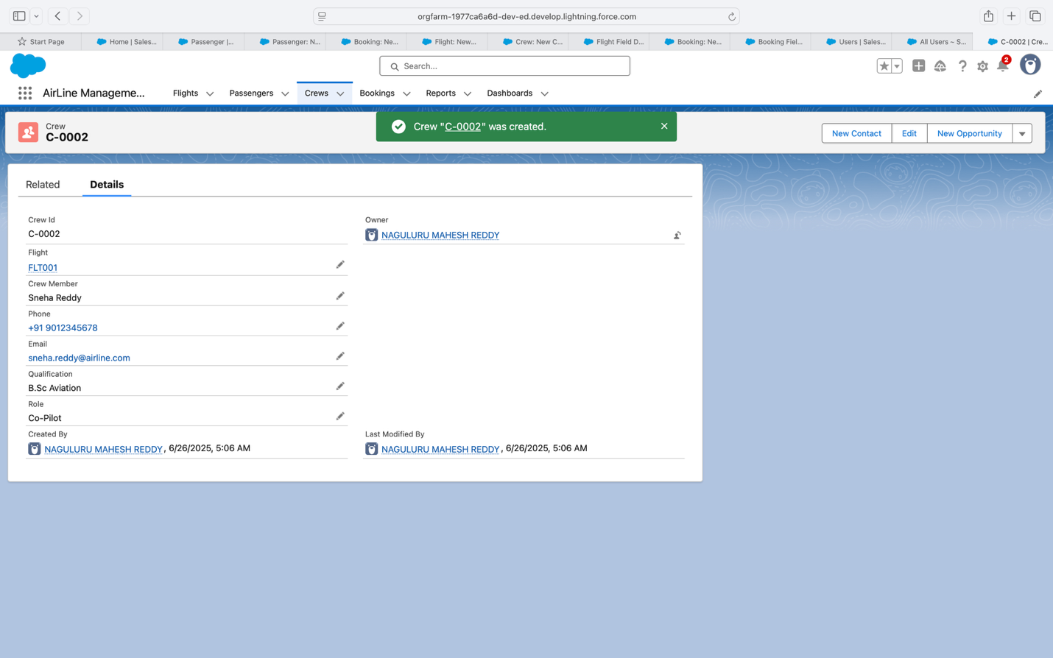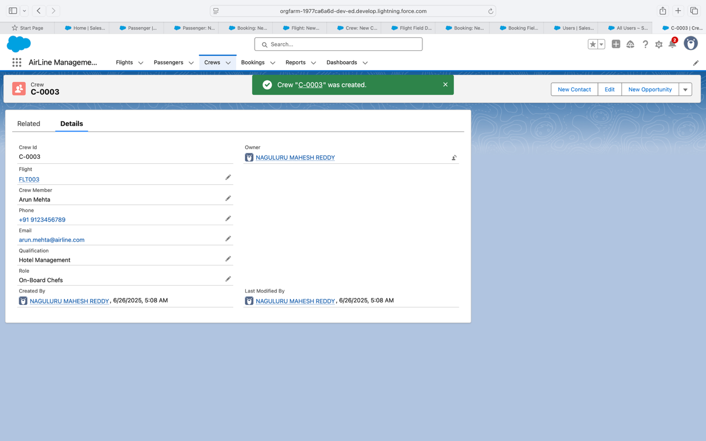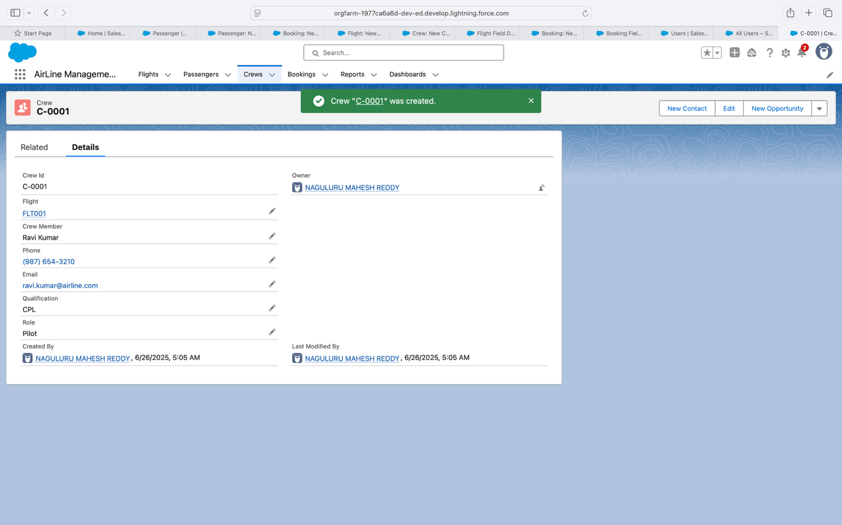

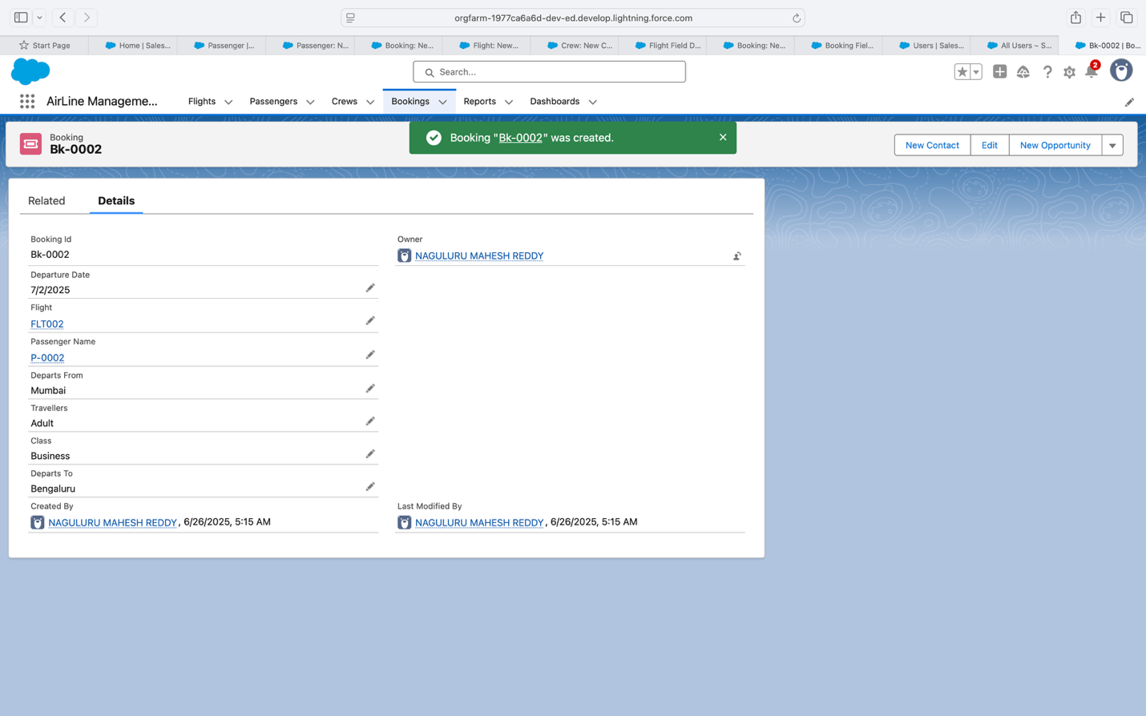

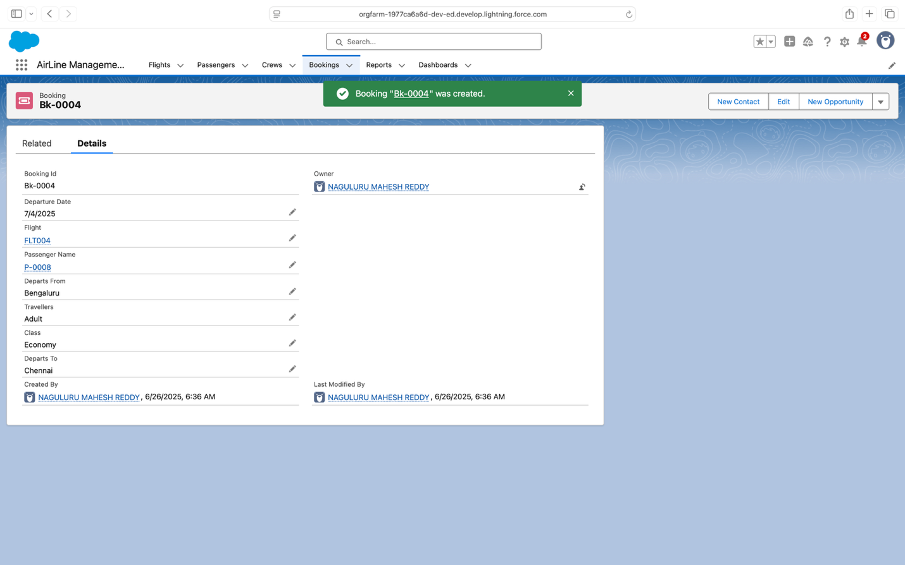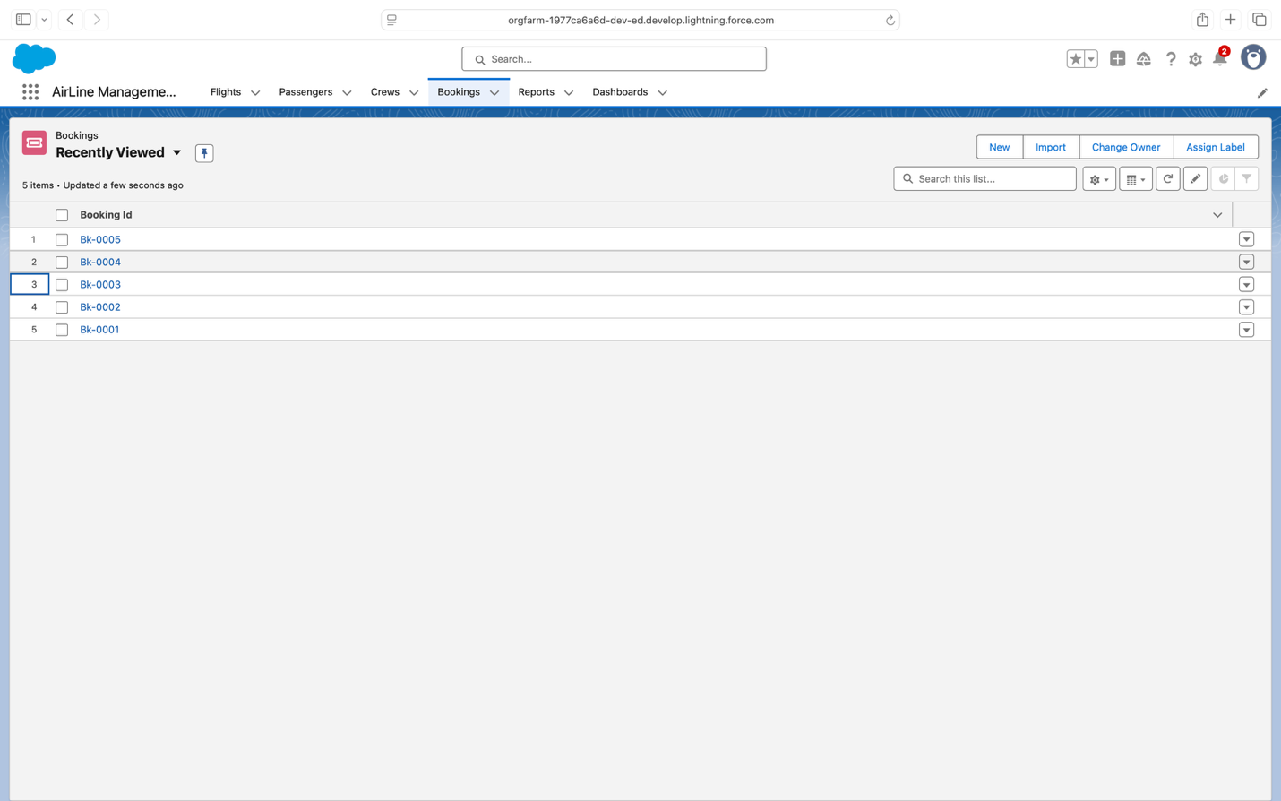

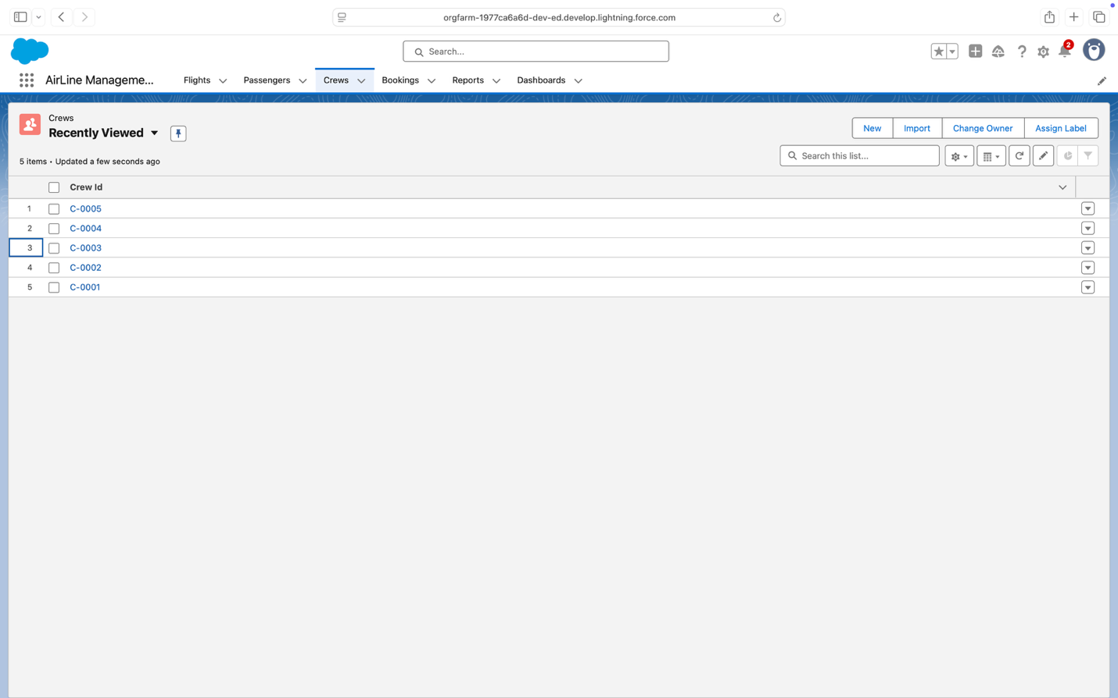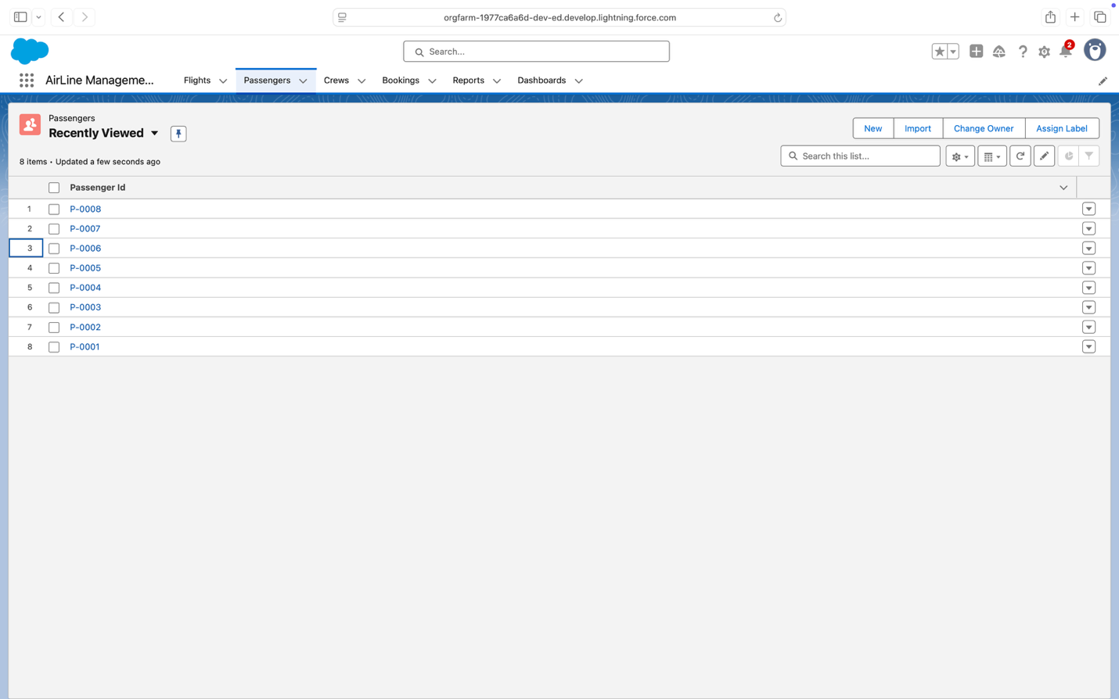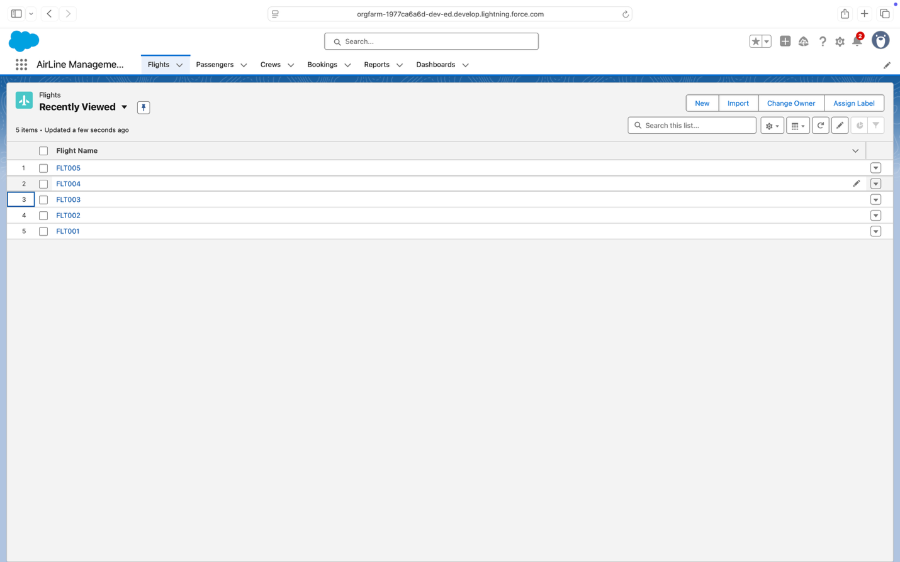

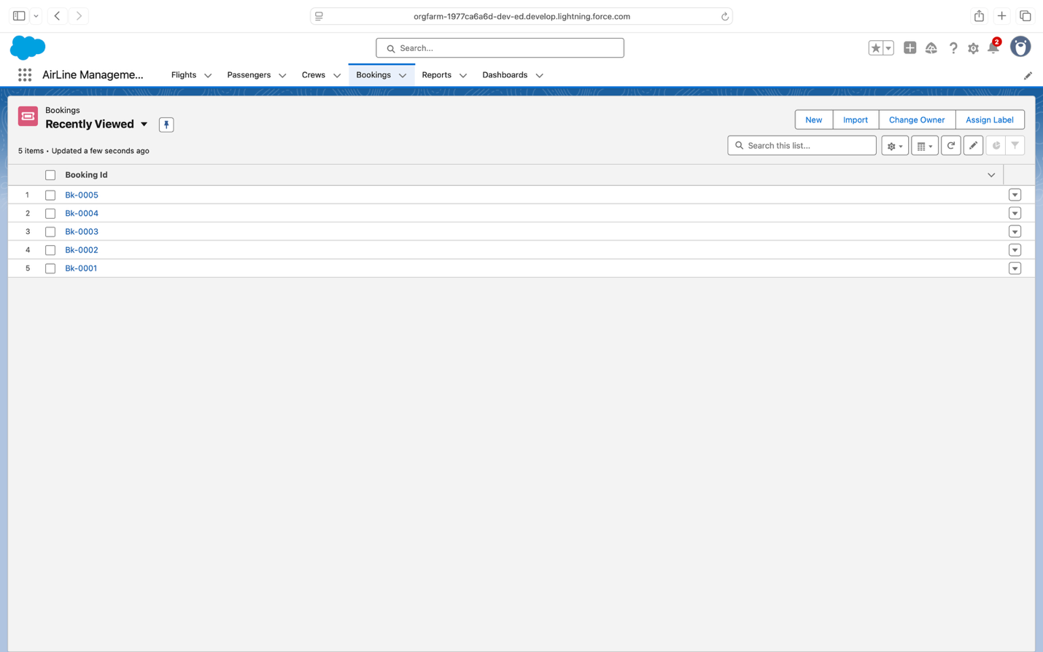

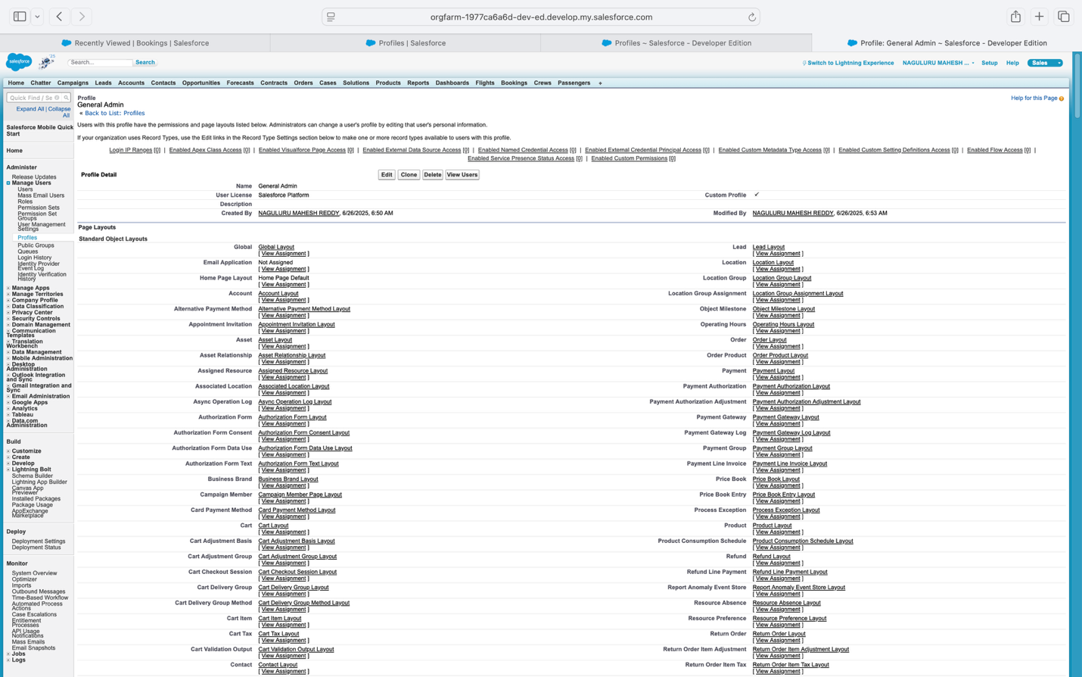



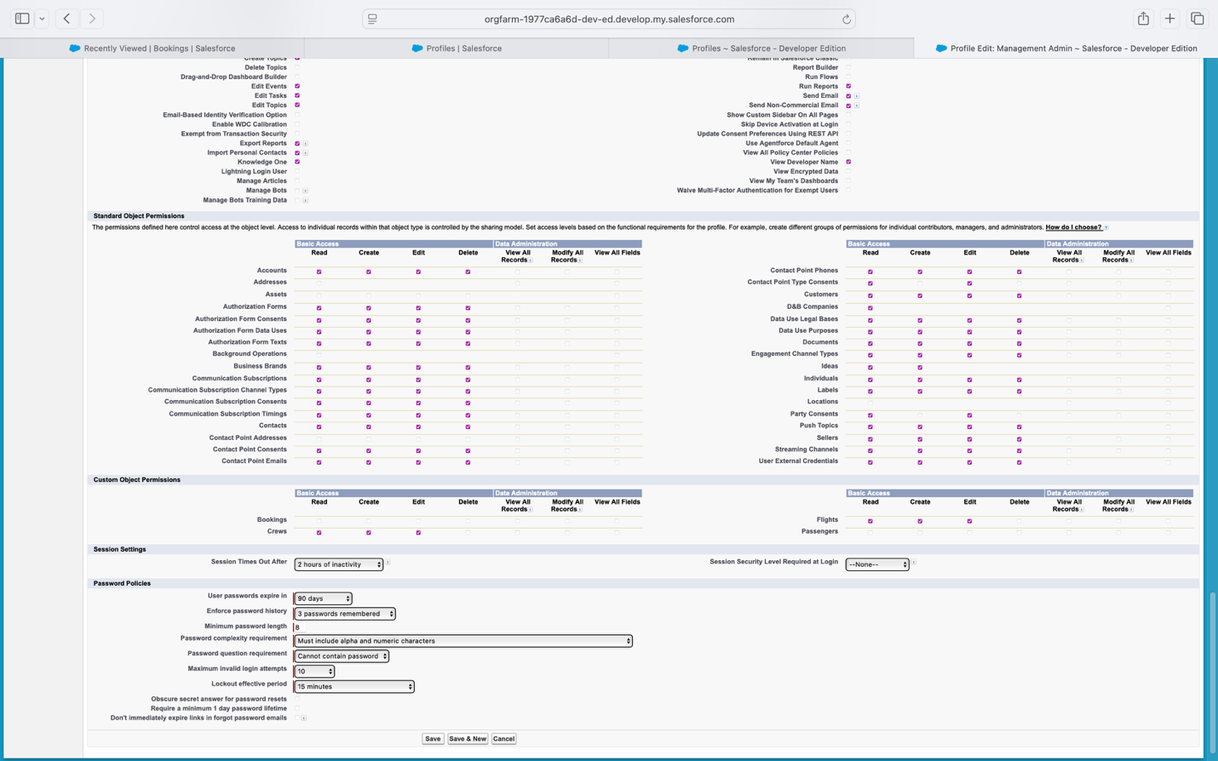

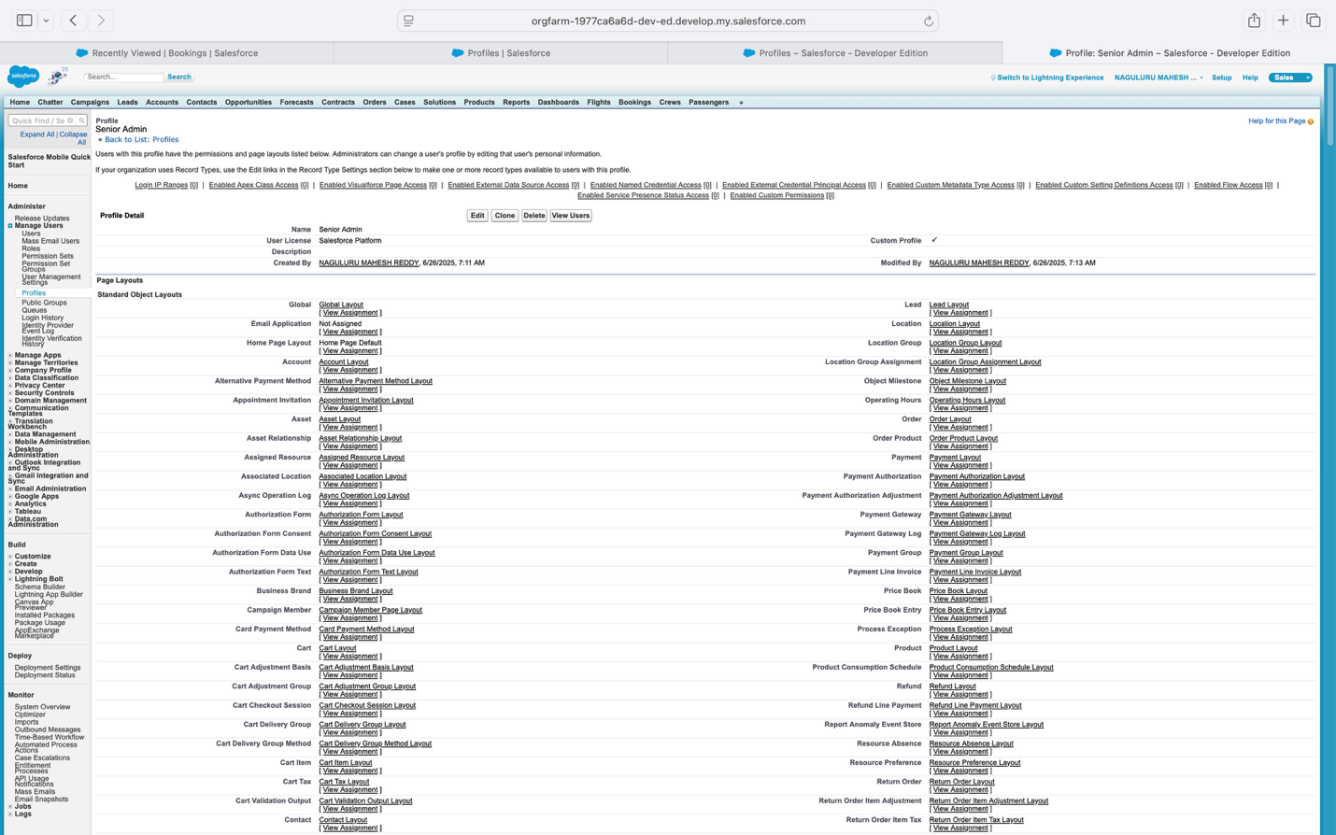

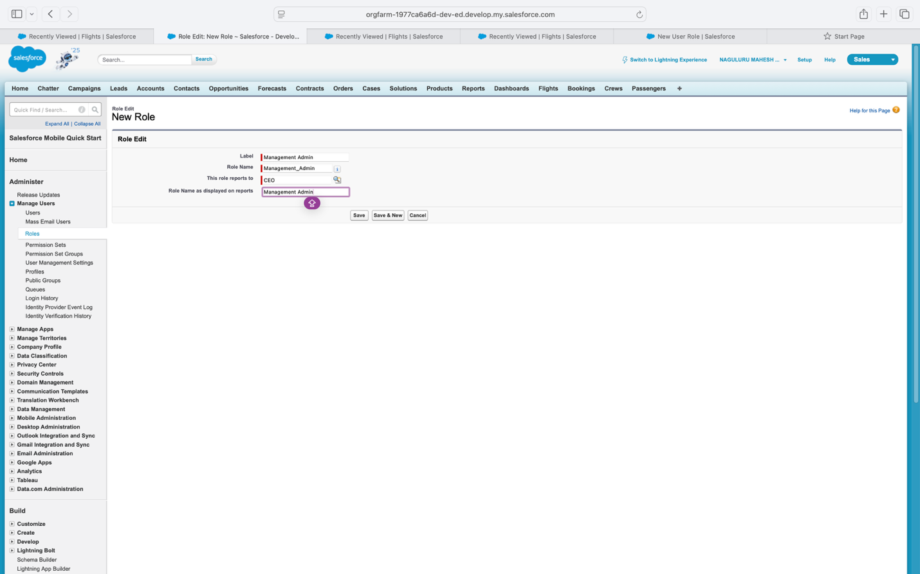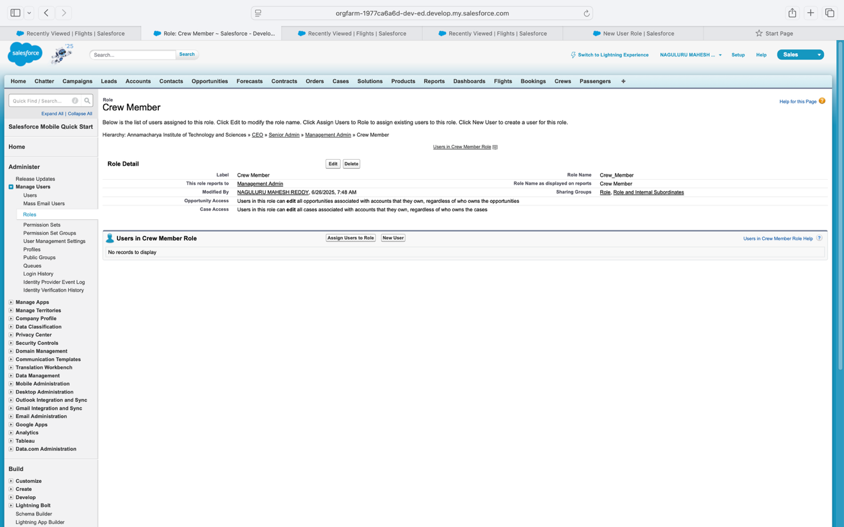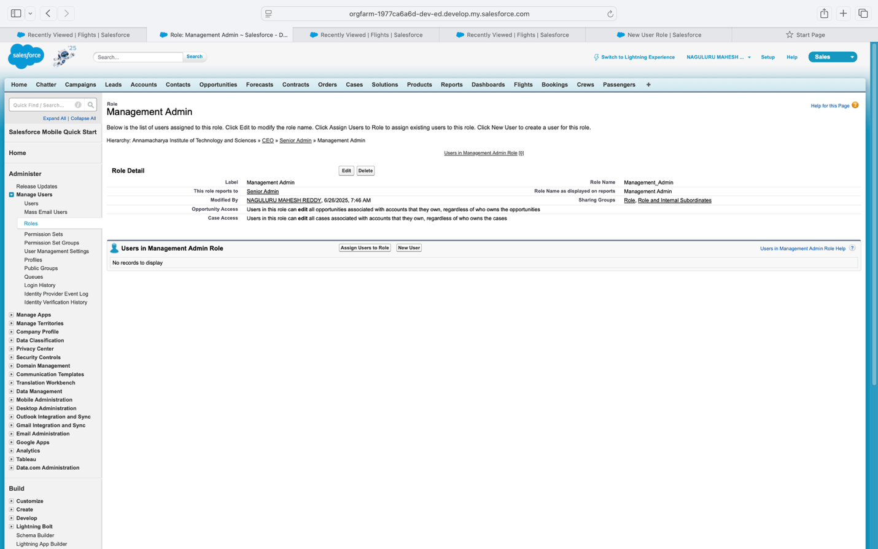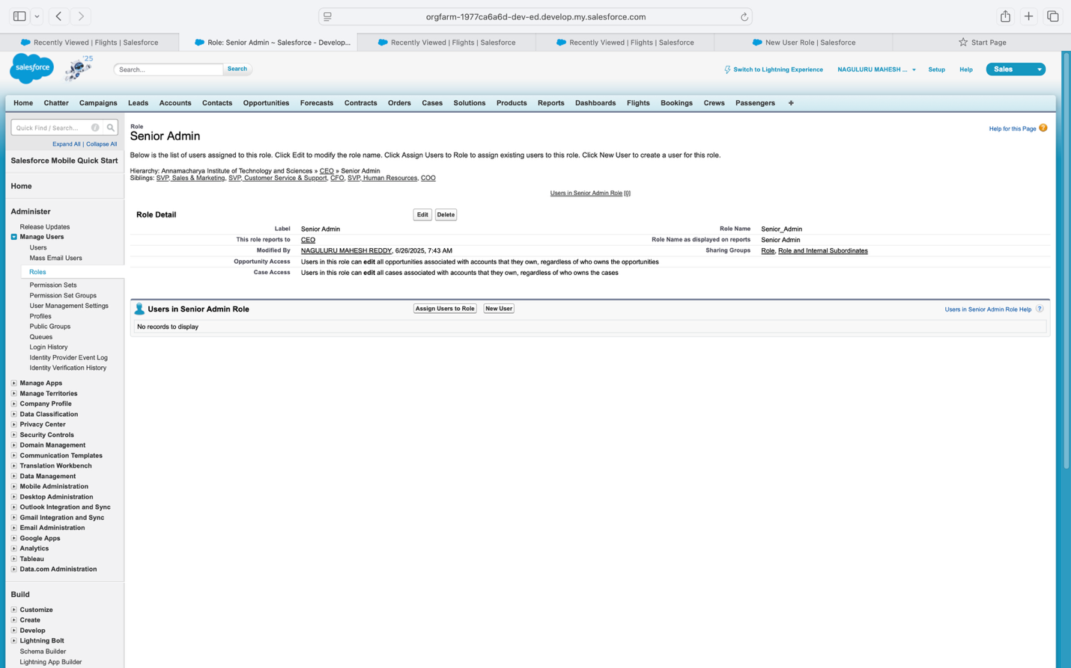

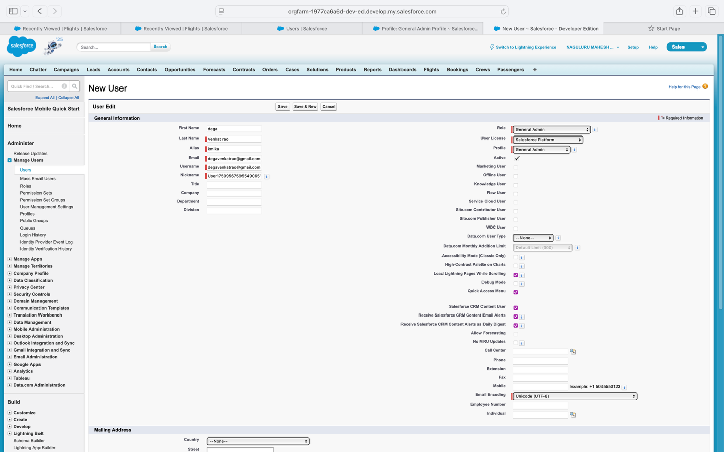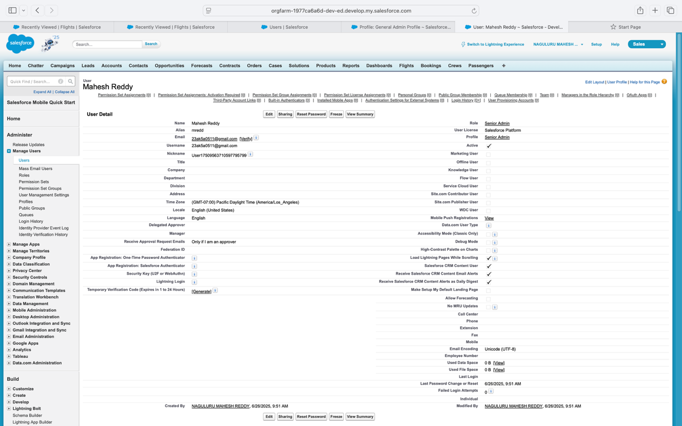

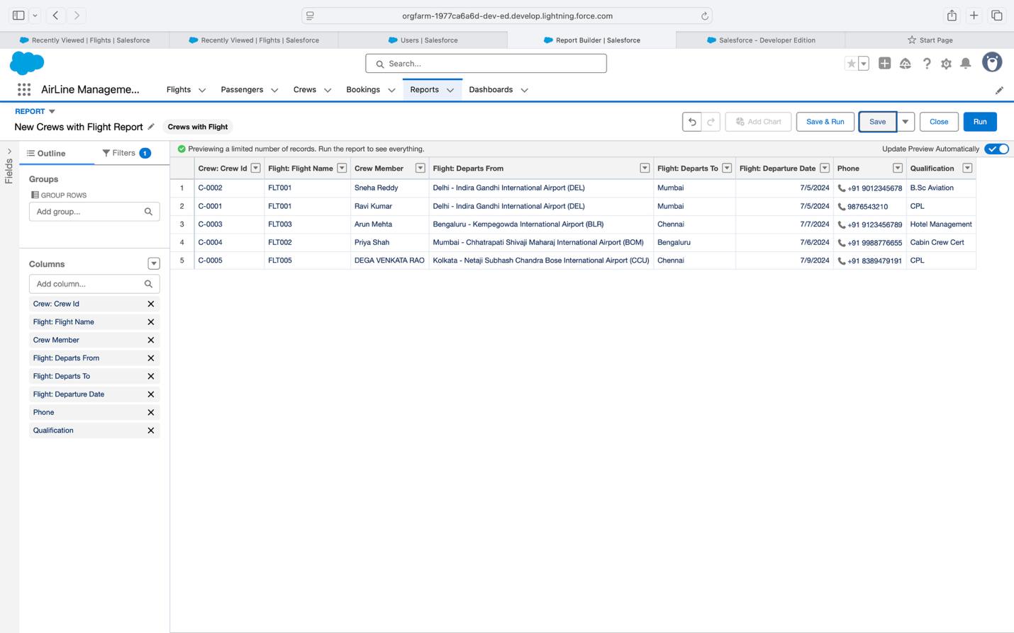

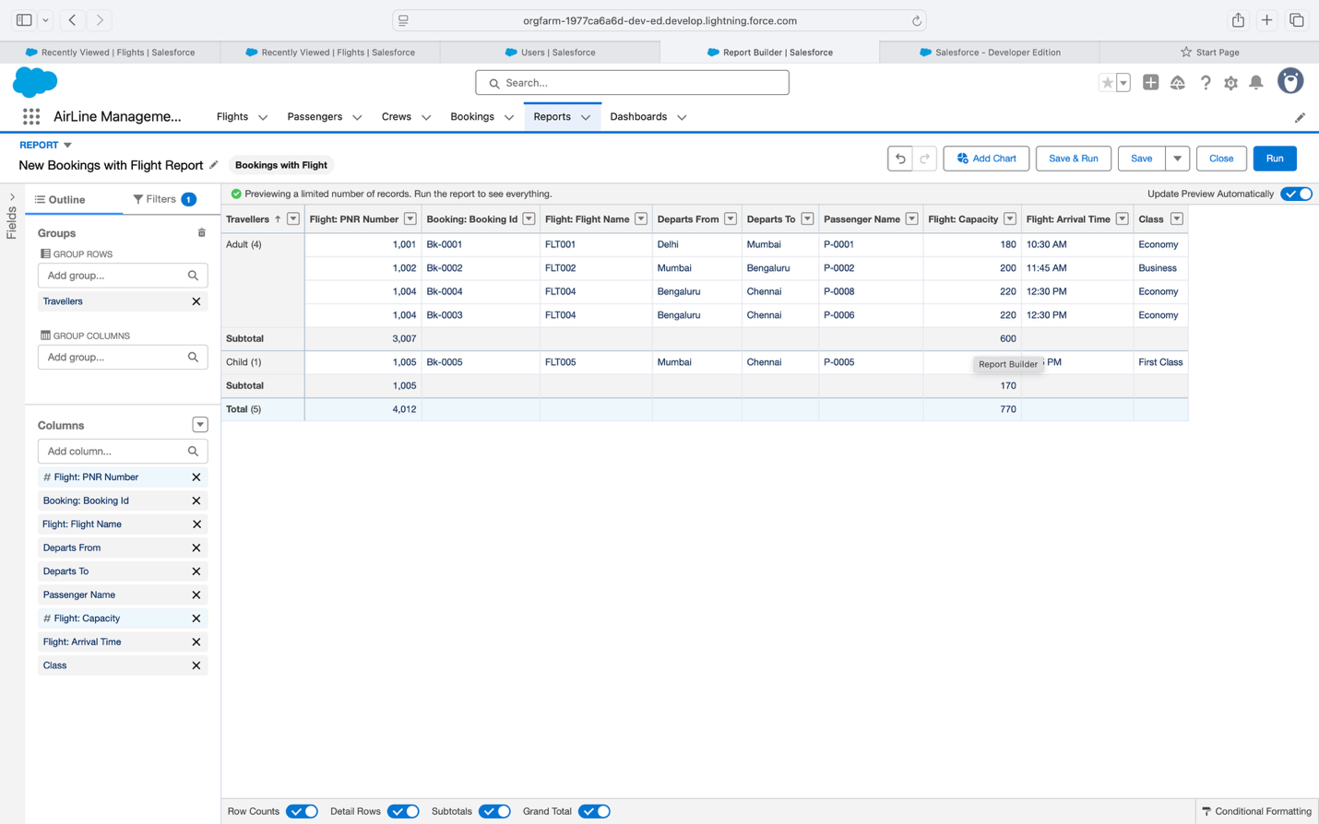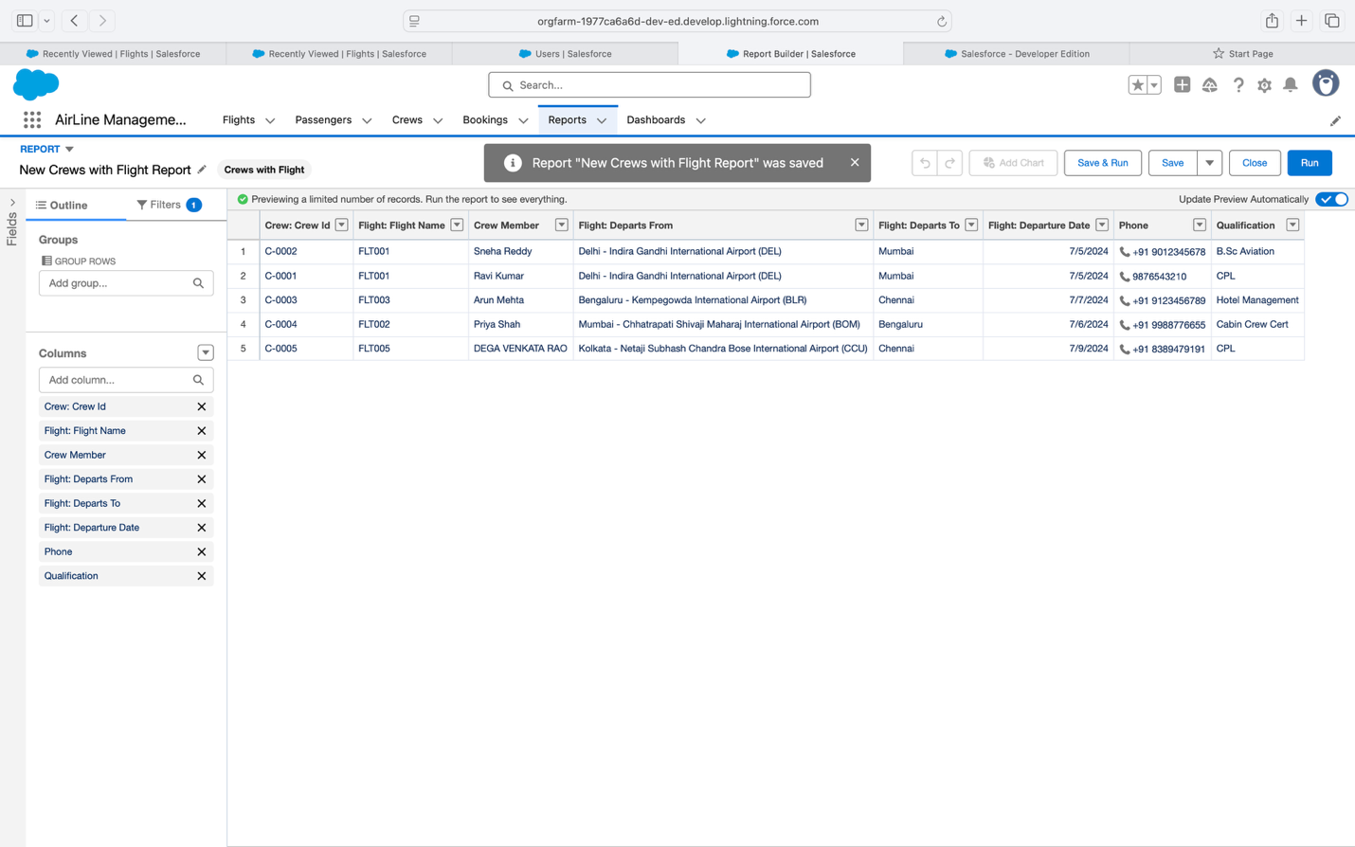

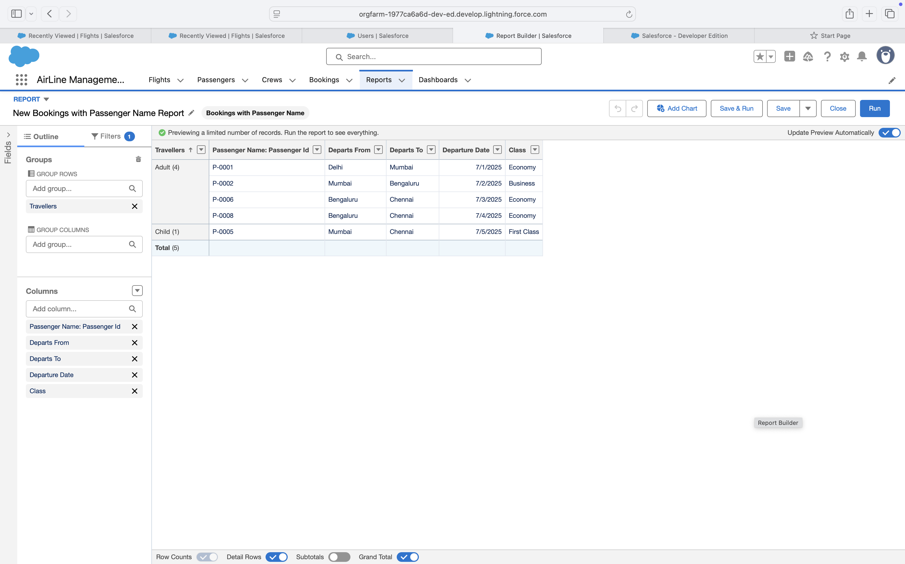

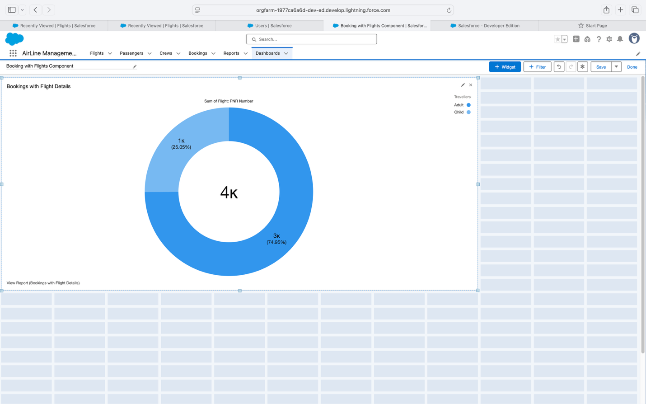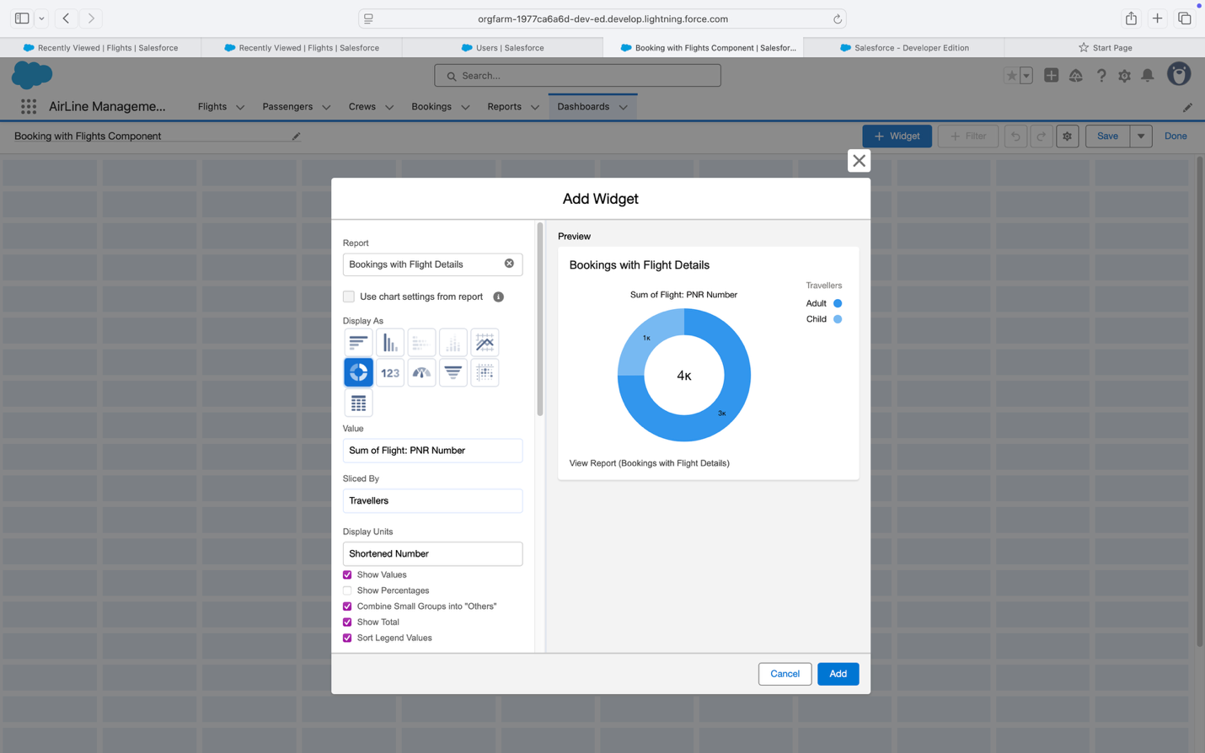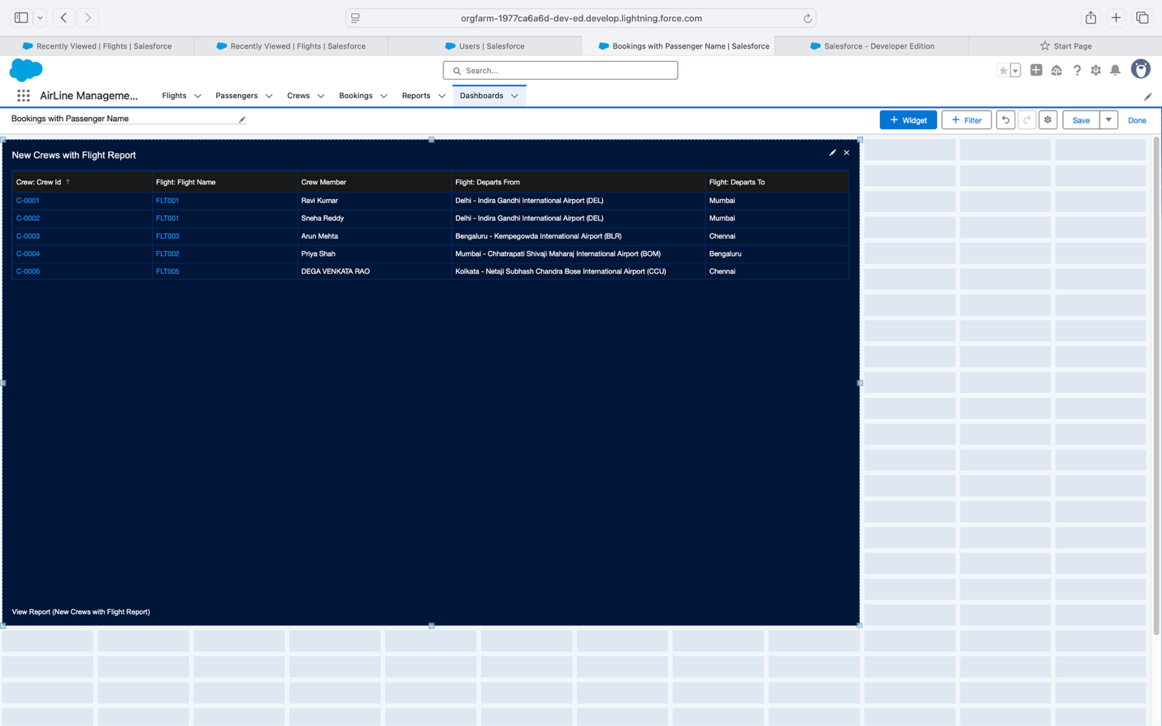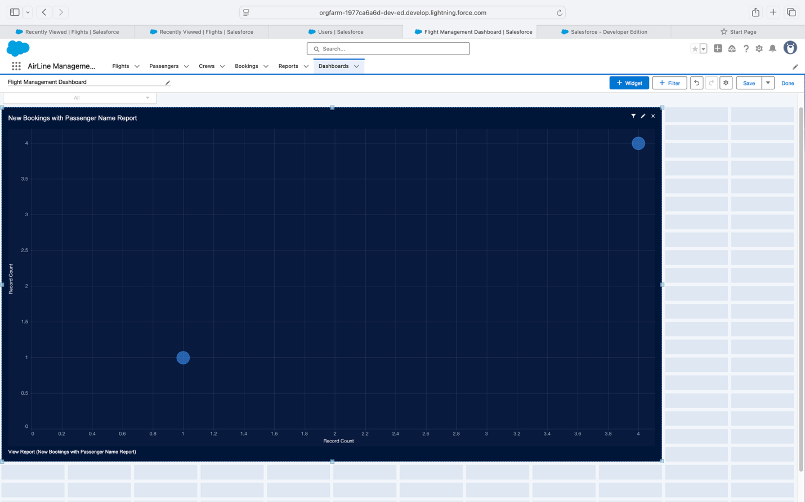

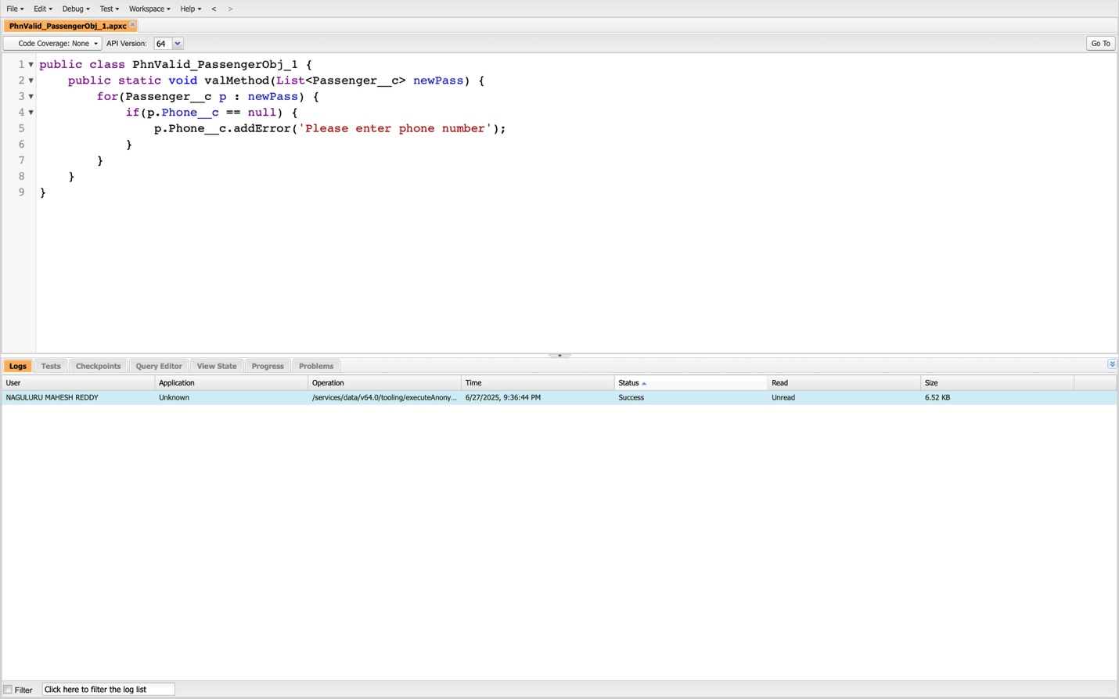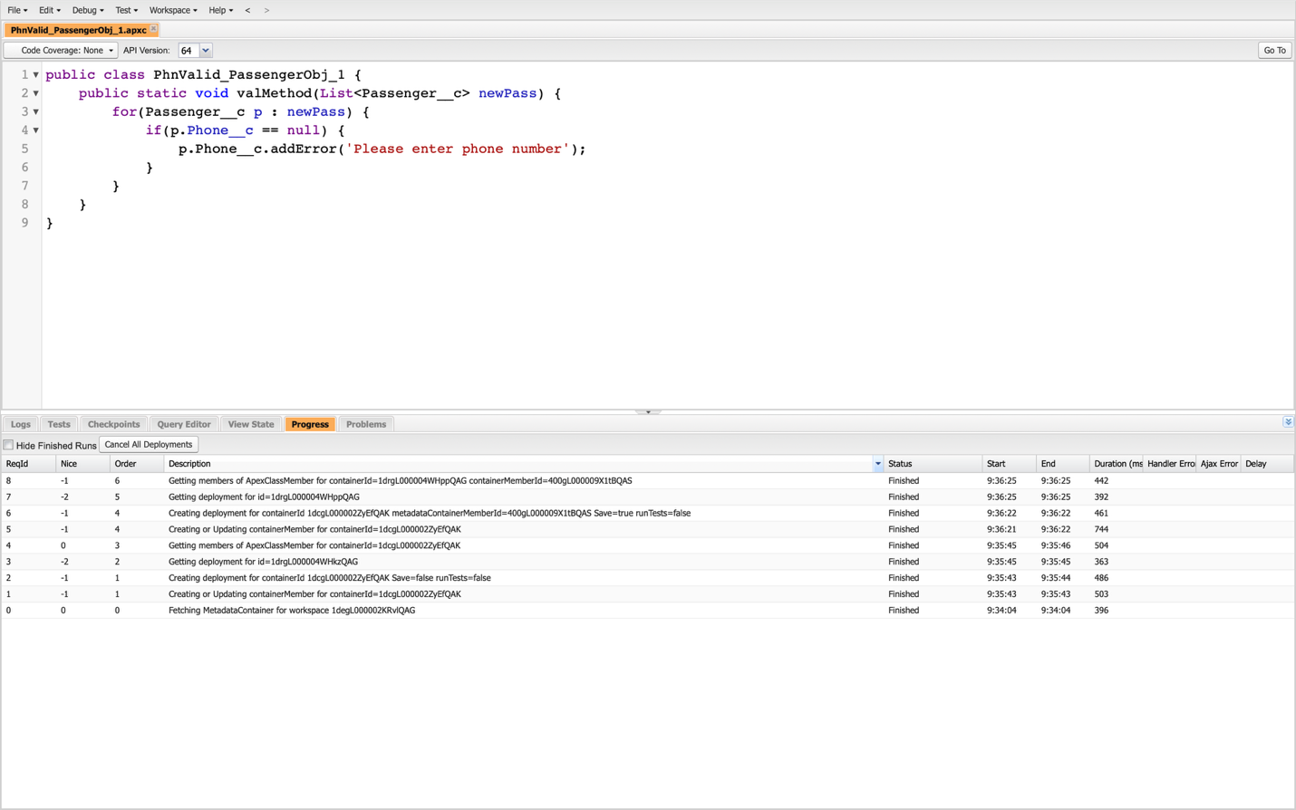

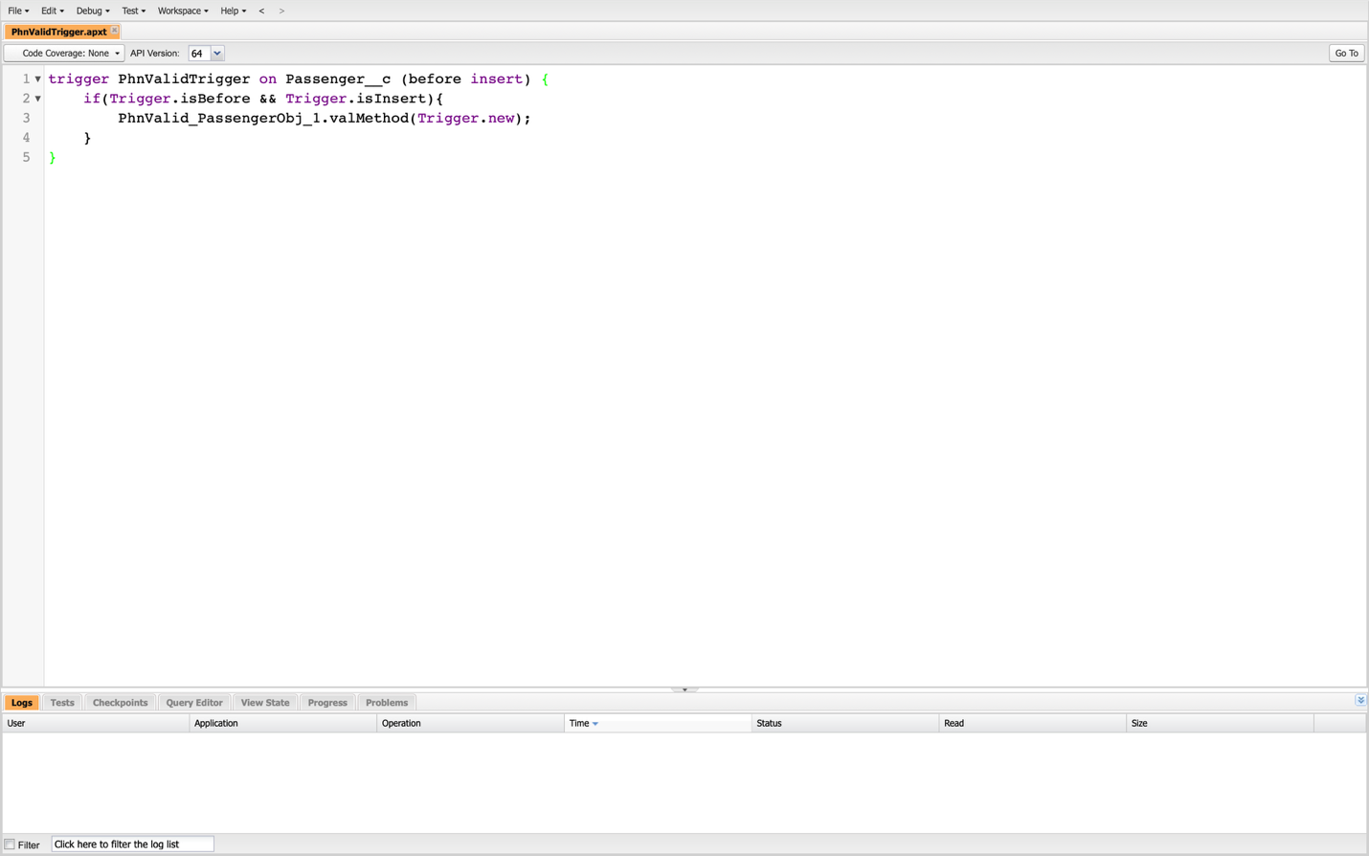

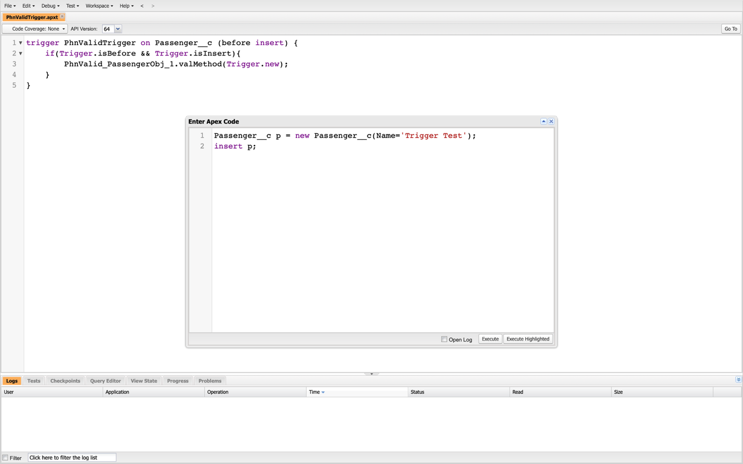

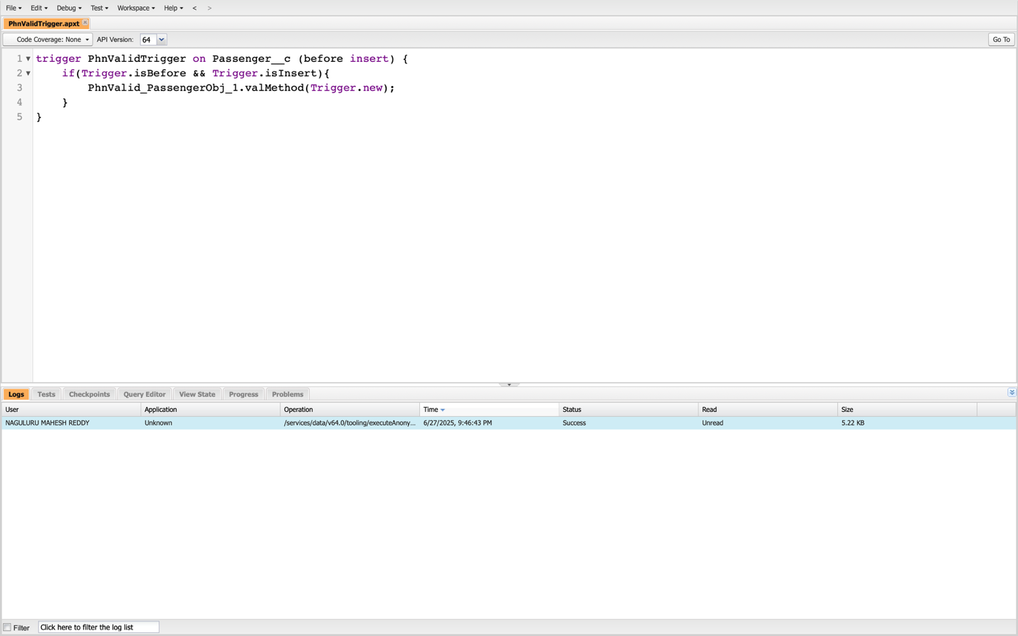

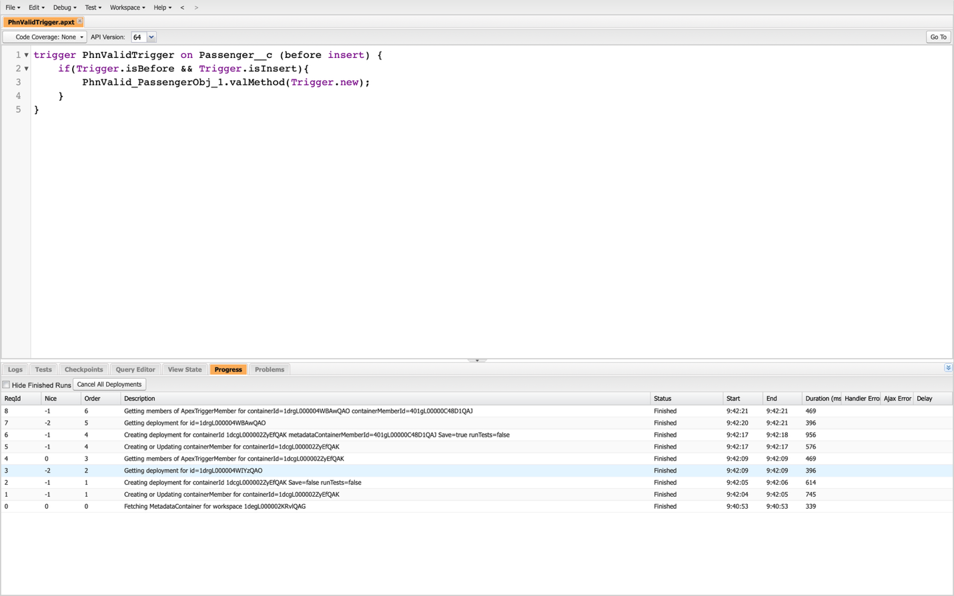

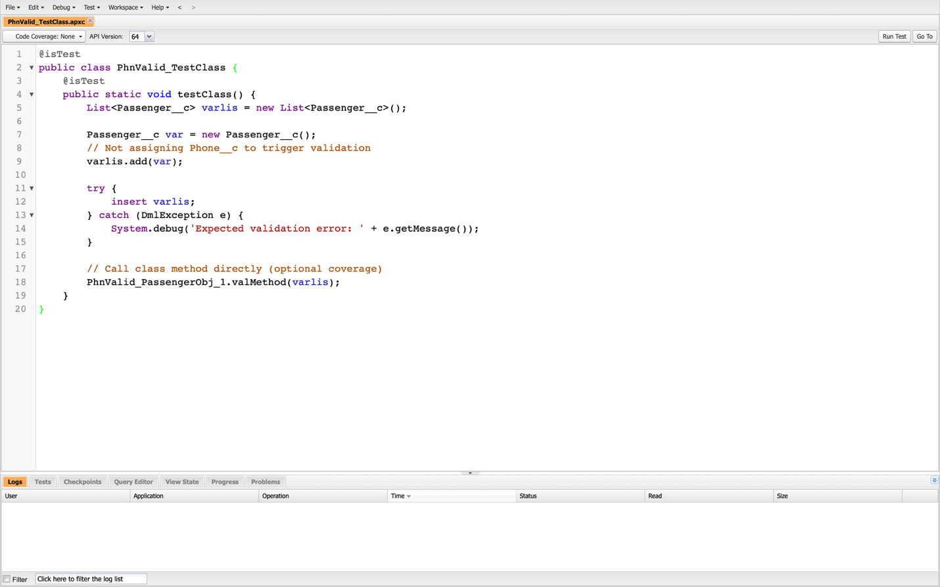

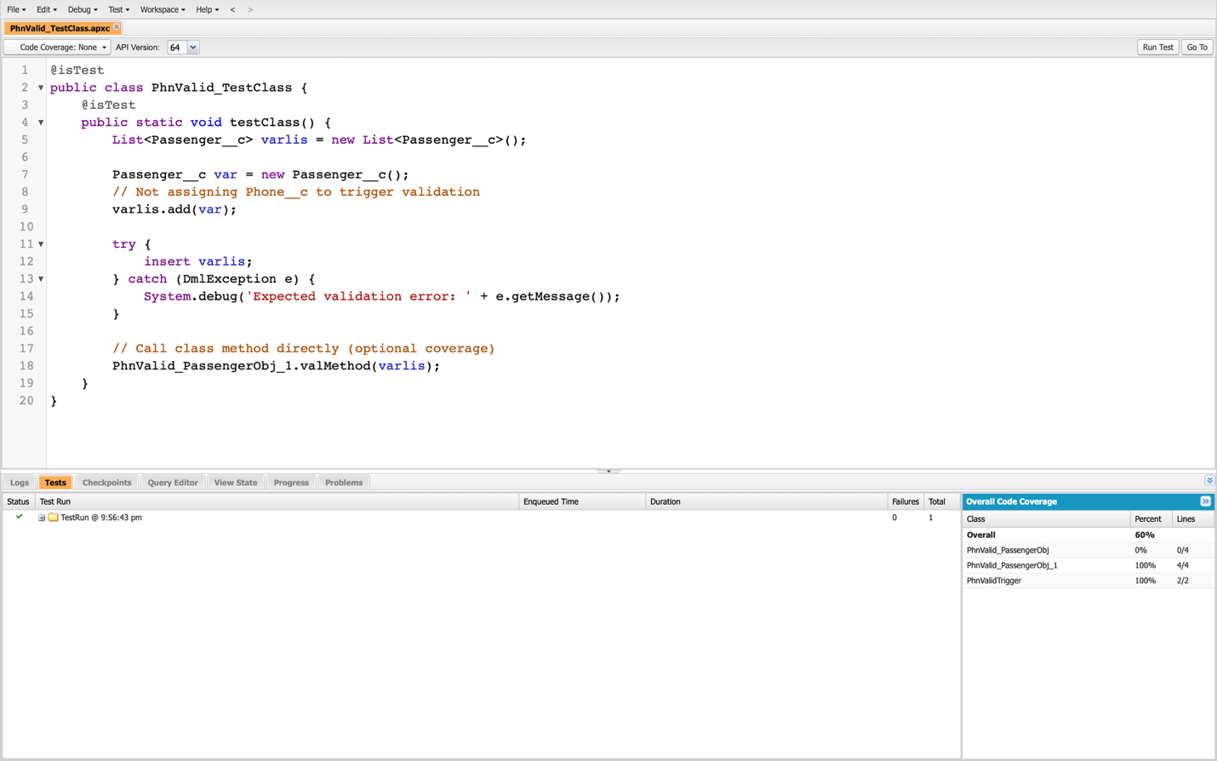

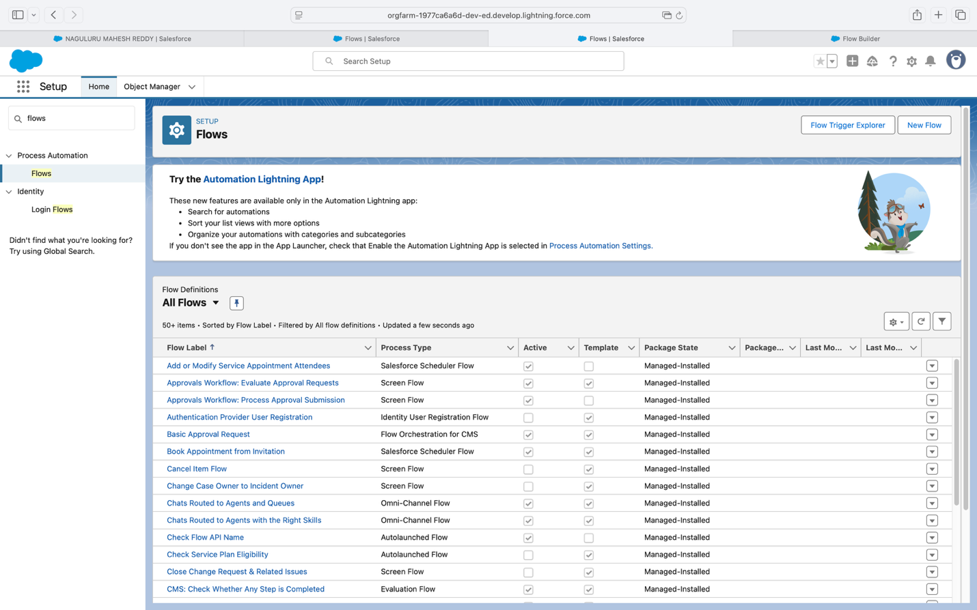

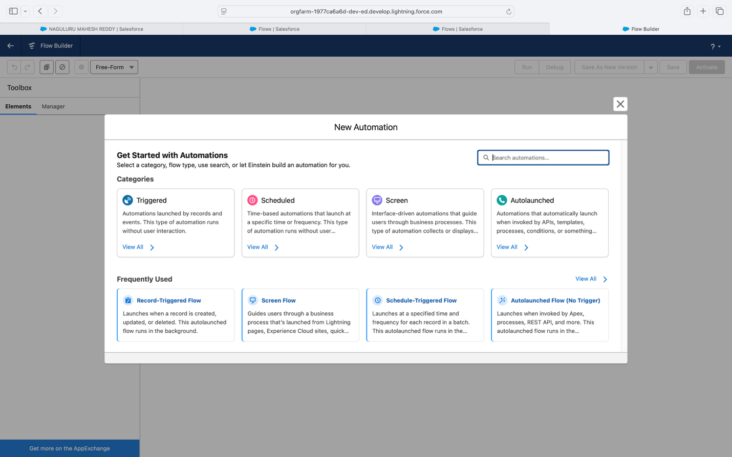

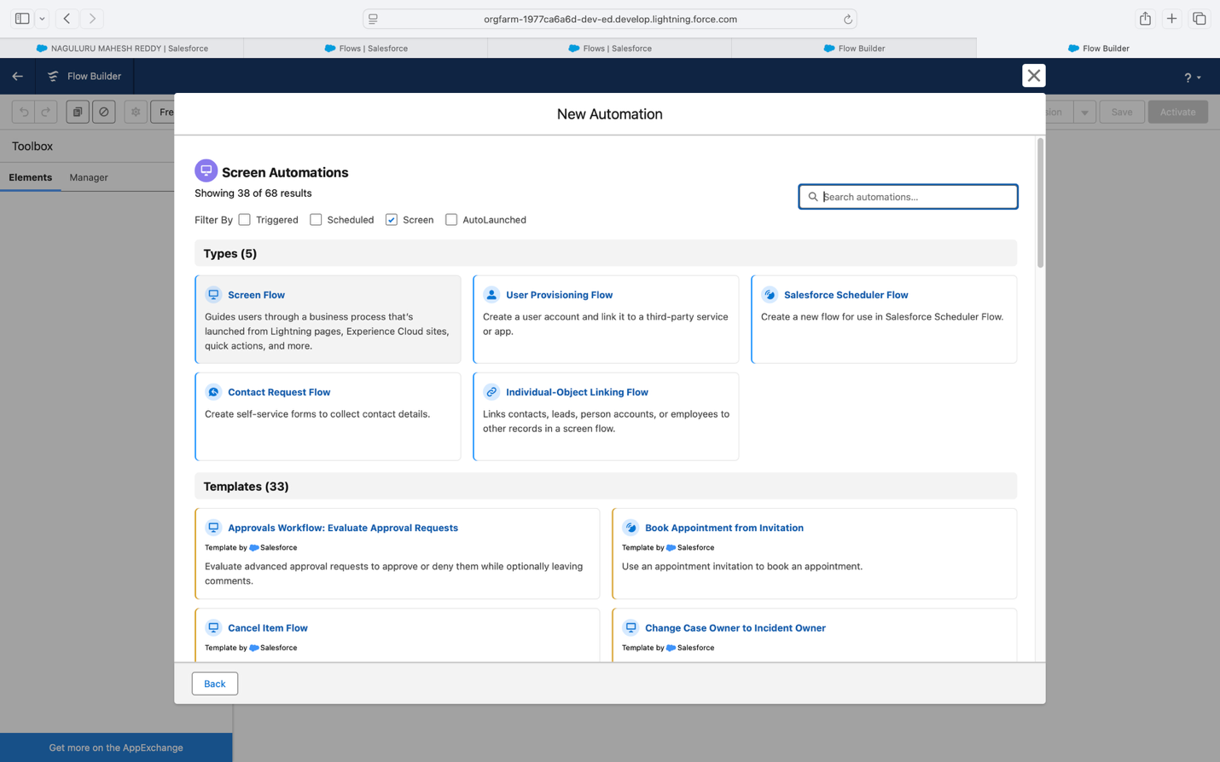

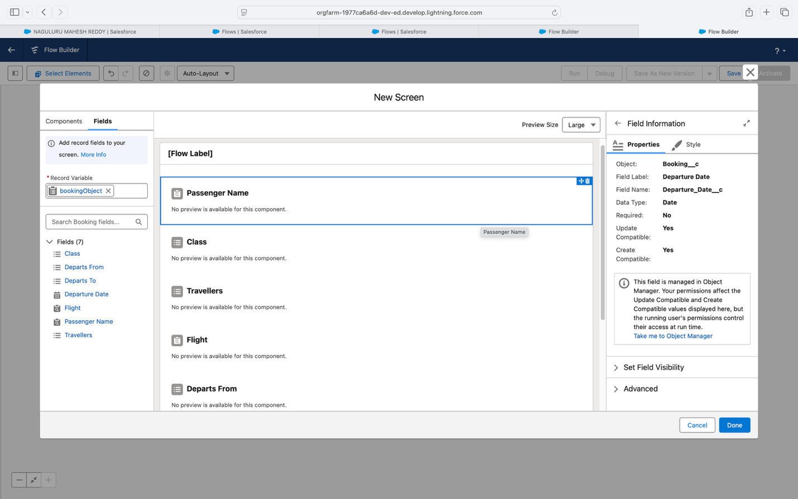

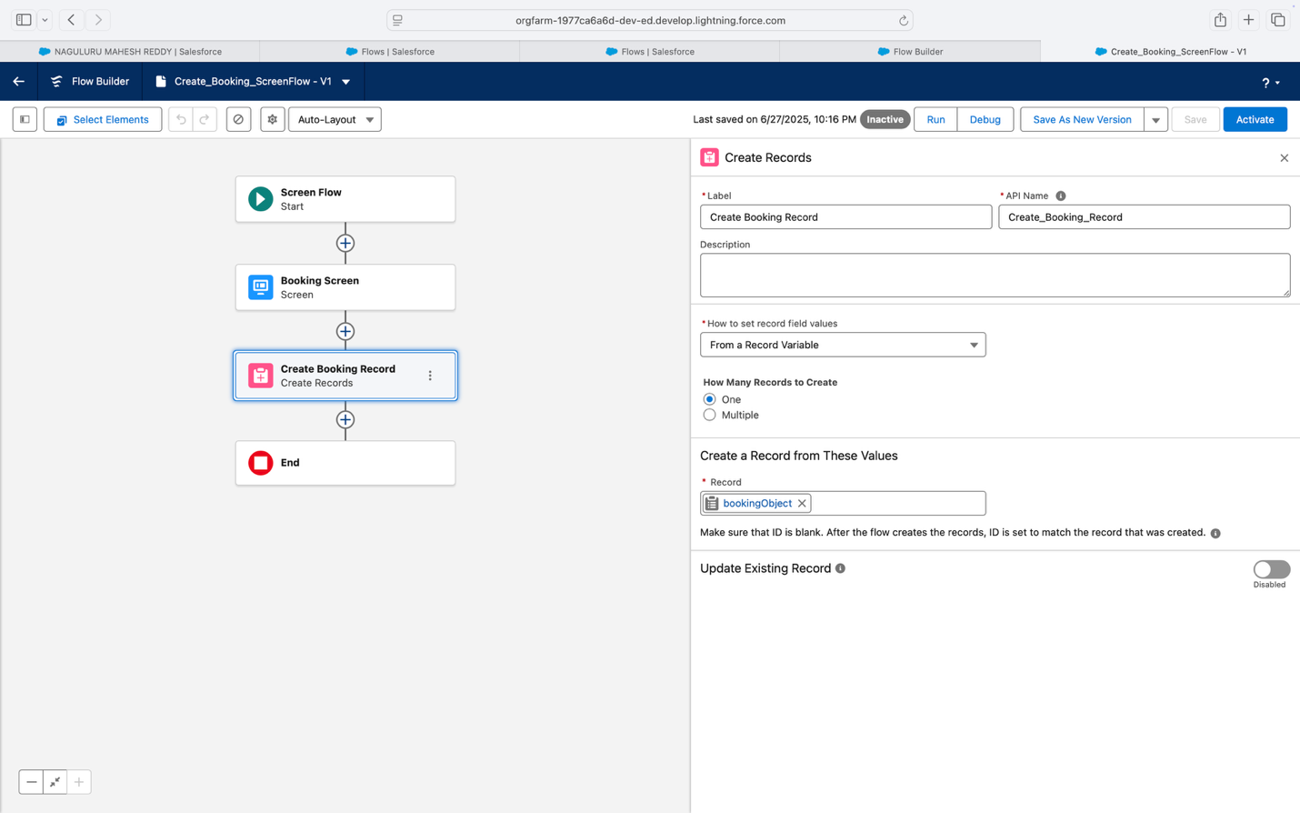

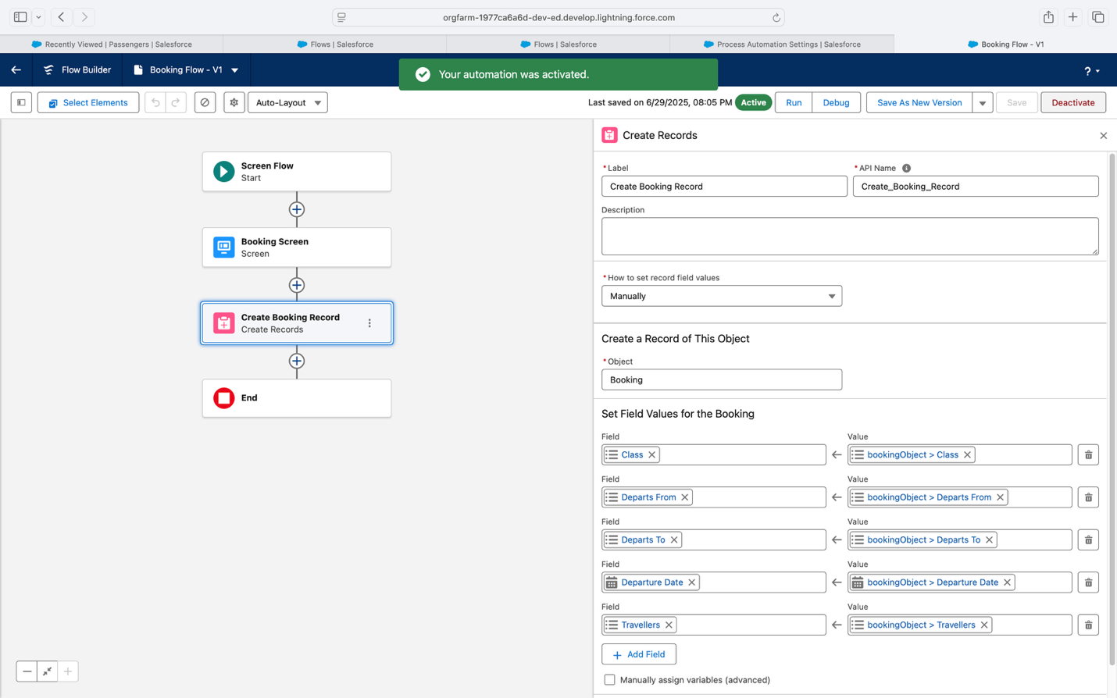

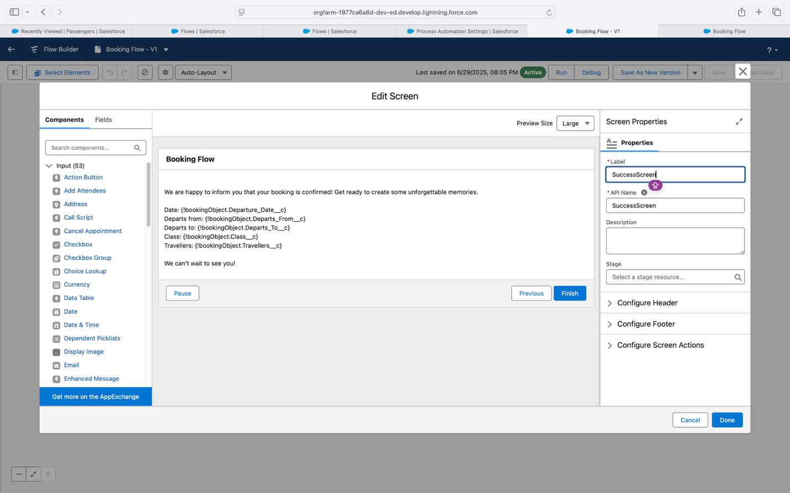

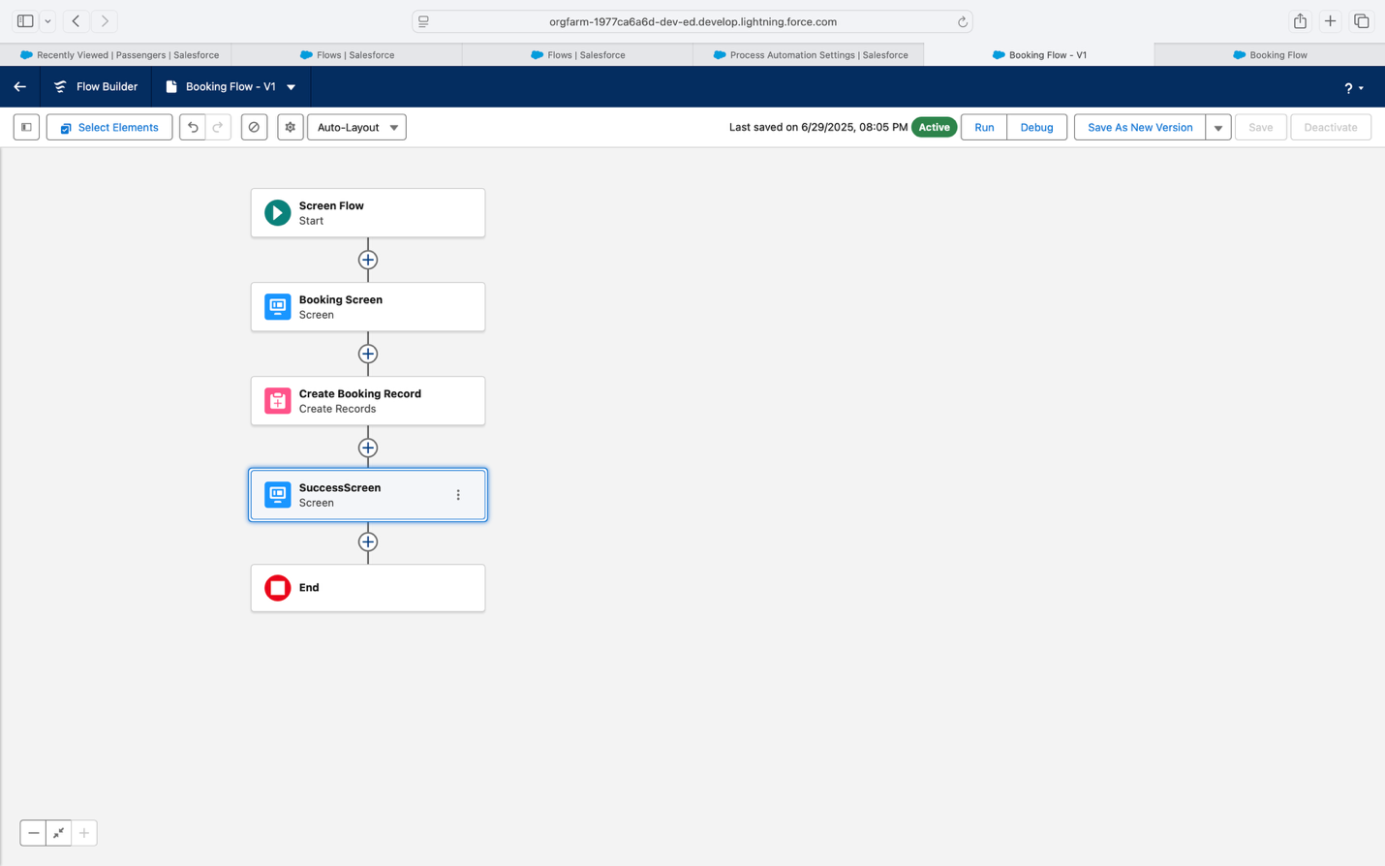

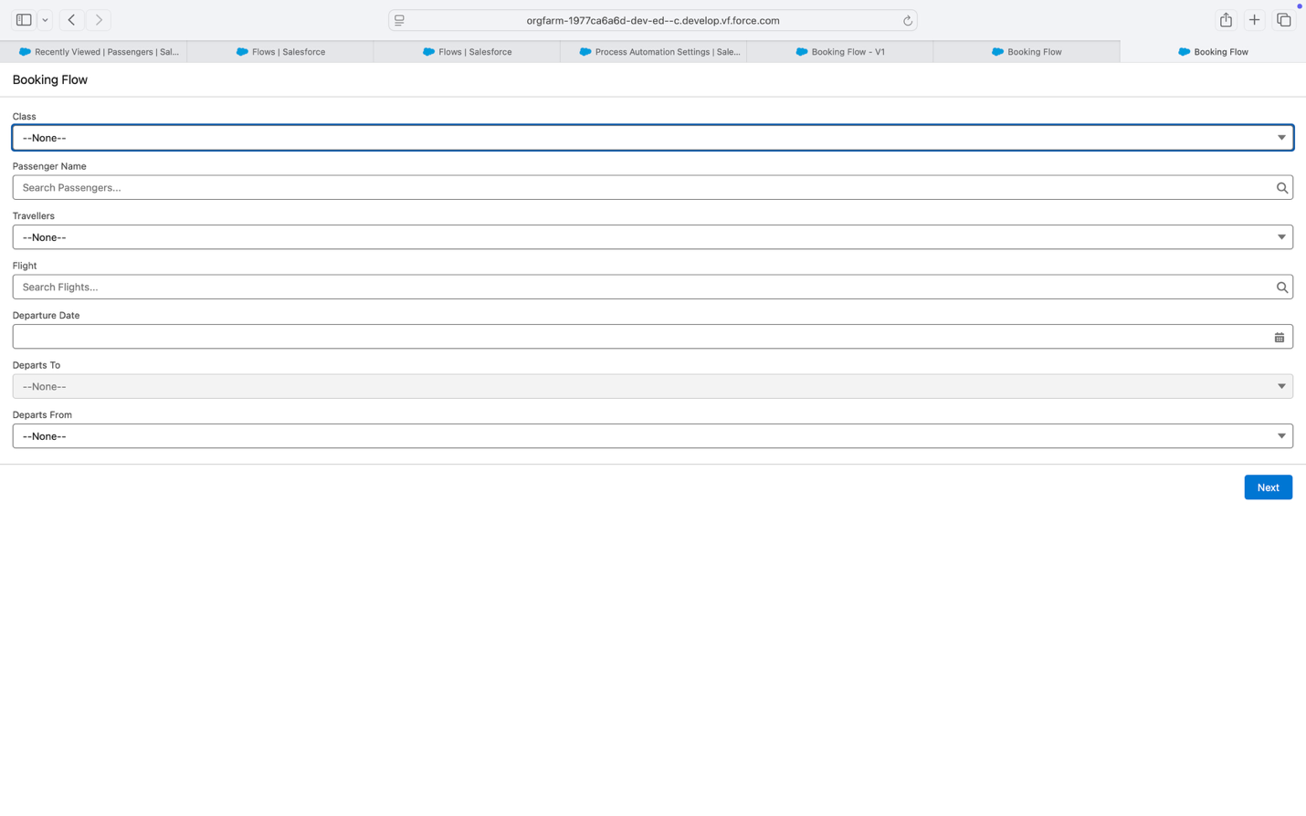

## **8. ADVANTAGES & DISADVANTAGES:**

### **7.1 Comparative Analysis: Before vs After Implementation**

| **Criteria** | **Before Implementation** | **After Implementation** |
| --- | --- | --- |
| **Flight Scheduling** | Manual using spreadsheets or logs | Centralized and automated via Salesforce |
| **Passenger Booking** | Offline/semi-digital | Real-time digital booking and management on Salesforce |
| **Crew Assignment** | Done via phone calls or Excel sheets | Automated assignment with alerts and availability tracking |
| **Data Visibility** | Disconnected across teams | Unified dashboards and analytics |
| **Approval Workflow** | Manual/verbal | Digital workflows with timestamped approvals |
| **Scalability** | Limited to current size | Easily scalable across more routes, aircrafts, and airports |
| **User Access Control** | Shared access, hard to track | Role-based access with profiles and permissions |
| **Audit Trail** | Not maintained or unreliable | Complete change history tracking for compliance and audits |

### **7.2 SWOT Analysis**

**Strengths**

* Real-time visibility into flights, bookings, and crew.
* Built entirely on Salesforce – secure, reliable, and scalable.
* Automation of approvals, alerts, and task assignments.
* Easy UI for staff, crew, and admin.
* Ready for future enhancements like customer feedback tracking and loyalty integration.

**Weaknesses**

* Requires internet connection.
* Salesforce licensing and customization may add initial costs.
* Onboarding/training time for ground staff and crew.

**Opportunities**

* Integrate with airport check-in systems and third-party booking portals.
* Expand into flight analytics and delay prediction.
* Enable real-time crew mobility updates via mobile apps.
* Create dynamic pricing modules based on load and time.

**Threats**

* Data breaches or access misuse if security policies are weak.
* Platform dependency on Salesforce’s uptime.
* Resistance to digital shift from legacy operational teams.
* Need to stay compliant with aviation and passenger data privacy laws.

## **9. FUTURE ENHANCEMENTS:**

To ensure the system remains relevant and adaptive to the dynamic needs of the aviation industry, several enhancements can be planned for future development:

### 1. Integration with Third-Party Systems

* Connect with airport check-in systems, travel agencies, and ticket aggregators like MakeMyTrip or IRCTC Air.
* Enable real-time sync with airline partners for code-share or multi-leg flights.

### 2. Mobile App Support

* Launch mobile apps for passengers and crew to manage bookings, check-in, and view schedules on the go.
* Enable push notifications for gate changes, delays, and personalized flight updates.

### 3. Predictive Analytics and AI

* Use machine learning to predict demand patterns and suggest dynamic pricing.
* Forecast crew availability and automate scheduling conflicts resolution.

### 4. Passenger Feedback & Loyalty Program

* Add modules for collecting passenger feedback after flight completion.
* Integrate a loyalty point system to reward frequent flyers.

### 5. IoT Integration

* Real-time monitoring of aircraft components using IoT devices.
* Enable alerts for in-flight conditions or pre-emptive maintenance.

### 6. Multilingual and Localization Support

* Offer user interfaces and communication in multiple languages for global passengers and staff.

## **10. CONCLUSION:**

The **Salesforce Airlines Management System** project has successfully modernized traditional airline operations such as flight scheduling, crew assignment, and passenger booking. It minimizes delays, boosts accuracy, and ensures real-time control by replacing manual workflows with an integrated cloud solution.

By using Salesforce’s powerful tools—including Lightning Pages, Flows, Apex, and Dashboards—the system ensures transparency, automation, and role-based security. Departments now benefit from automated alerts, visual analytics, and efficient approval workflows, all while reducing operational overhead.

This system is scalable, secure, and ready for integration with advanced features like predictive analytics, real-time check-ins, and multi-airport deployment. It improves both airline staff productivity and the passenger experience.

In conclusion, the **Salesforce Airlines Management System** stands as a future-ready digital solution built to improve operational control, safety, and responsiveness in modern airline management.

## **THANK YOU**

### **A Special Thanks to Smart Internz**

For providing the opportunity, mentorship, and support throughout the project journey. Your platform enabled us to apply our learning in a real-world scenario and build a valuable, industry-relevant solution.

### **Project Team (Team ID: LTVIP2025TMID31510)**

• Team Leader: **Tejasree**

• Team Member: **Dega Venkatarao**

• Team Member: **Aluru Omnath Reddy**

• Team Member: **Naguluru Mahesh Reddy**